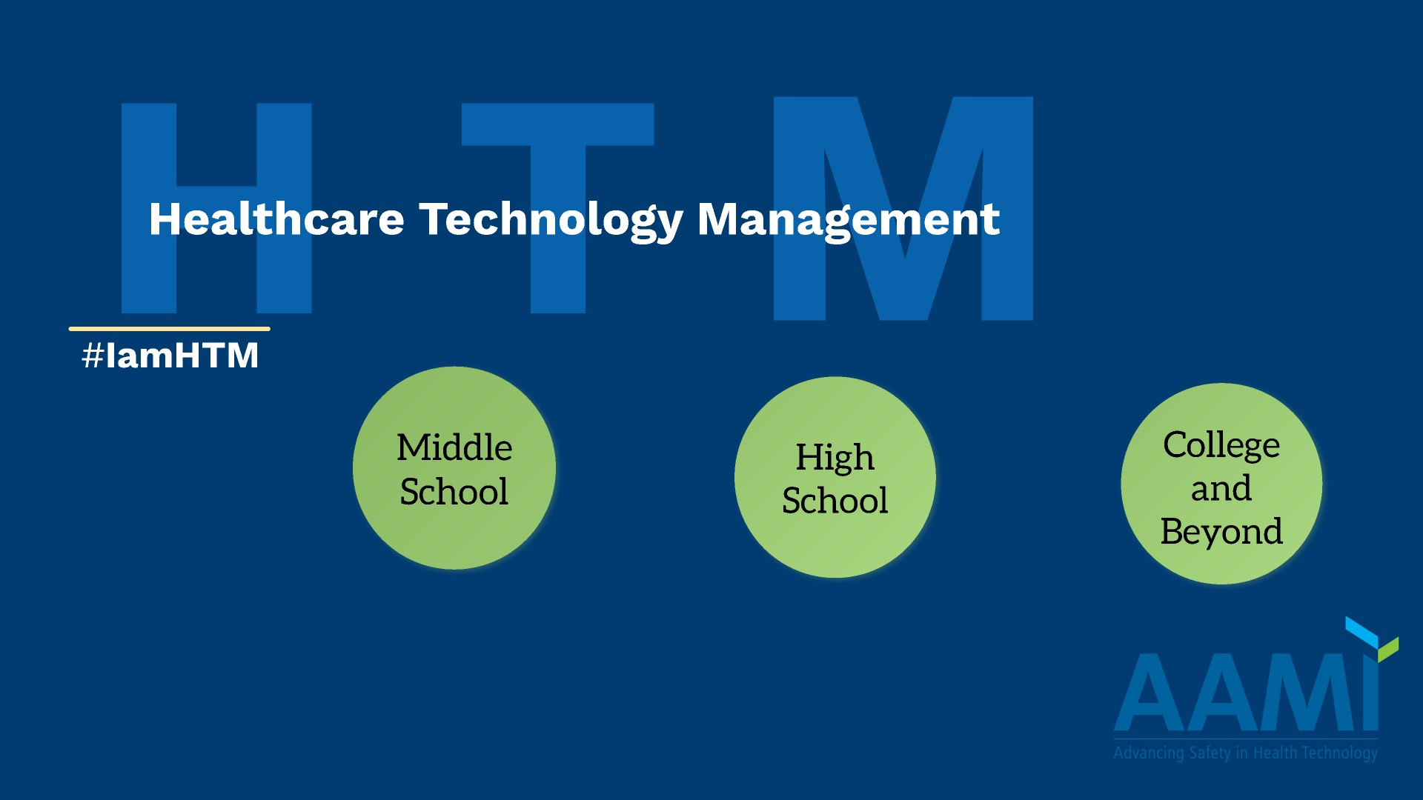

Notes:
- These presentations were created to be quick and to the point. Each presentation should not be longer than 15 minutes of speaking time to not lose the audience’s attention.
- Each presentation is generic. You can customize each presentation by providing stories, information and examples that are personal to you, your employer, and your geographical area.
- The Middle School Presentation is very basic and targeted for students up to the 5th/6th Grade. For 7th and 8th graders, the High School presentation is more age appropriate.

Notes:
- This page should be used to introduce yourself. Once you have done that, you could say: “Today we are going to talk about Healthcare Technology Management and what an exciting career it is!”

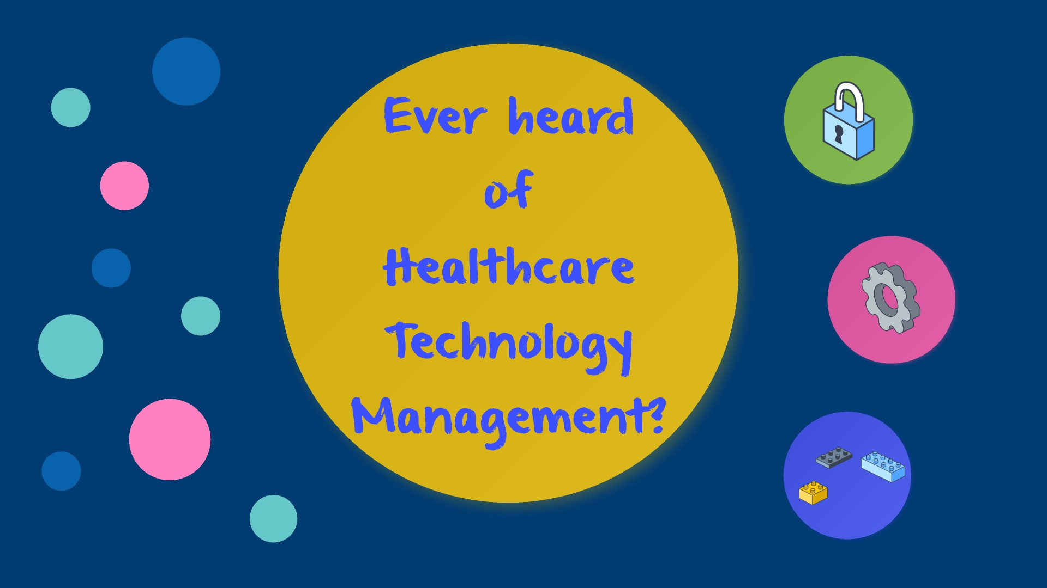

Notes:
- This is a great slide to solicit ideas from the audience about what they think HTM is by asking this question and getting them involved. Break down the title if needed to help them guess.
- You can give a general example about the field’s work such as being called in during the middle of a surgery case to help get the equipment going. Just remember to keep the conversation light and easy to understand for this age group.

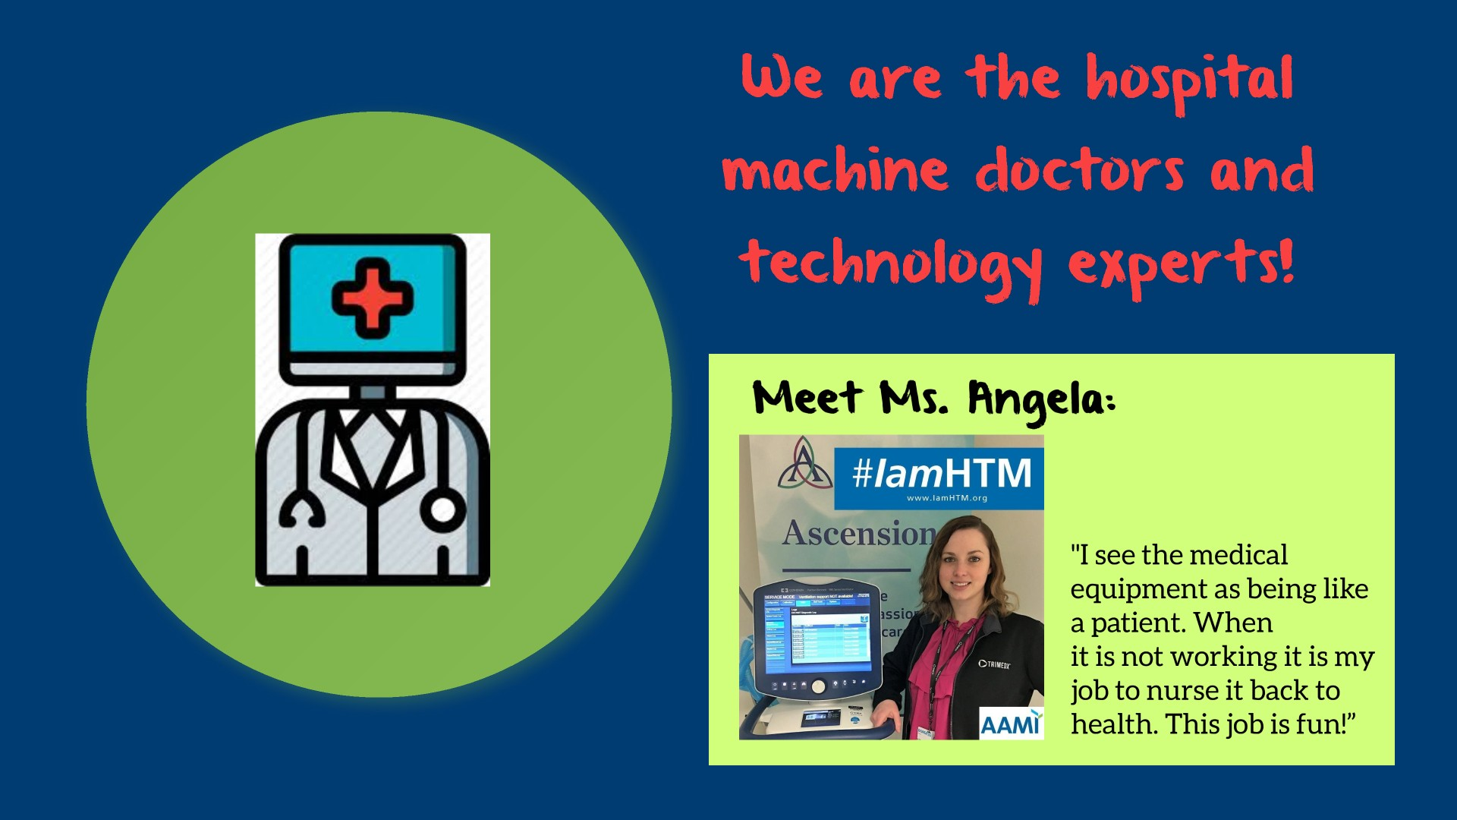

Notes:
- Make the analogy that much like how people get sick, the equipment also breaks down over time and needs to be fixed/nursed back to health.
- Depending how young the age group is, you can relate this to changing batteries in toys, or, if the group is a bit older, you can relate this to fixing a car. Cars need oil and filter changes to keep running well and the medical equipment also needs that same kind of work.

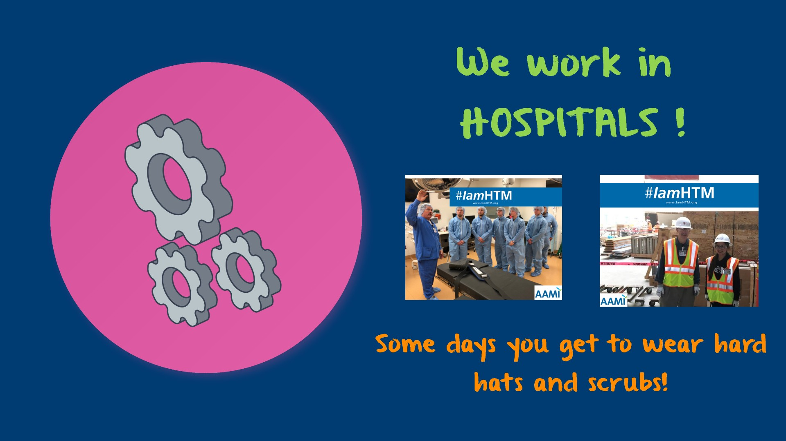

Notes:
- Reinforce that we have one of the coolest jobs in the hospital. Explain that HTM Professionals do work everywhere in the hospital.
- Ask the audience to name different areas of the hospital and give an example of what types of equipment we support in that area. Remember, keep it simple.
- Mention that we help design new hospital buildings and get to wear different outfits depending upon where we work in the hospital.

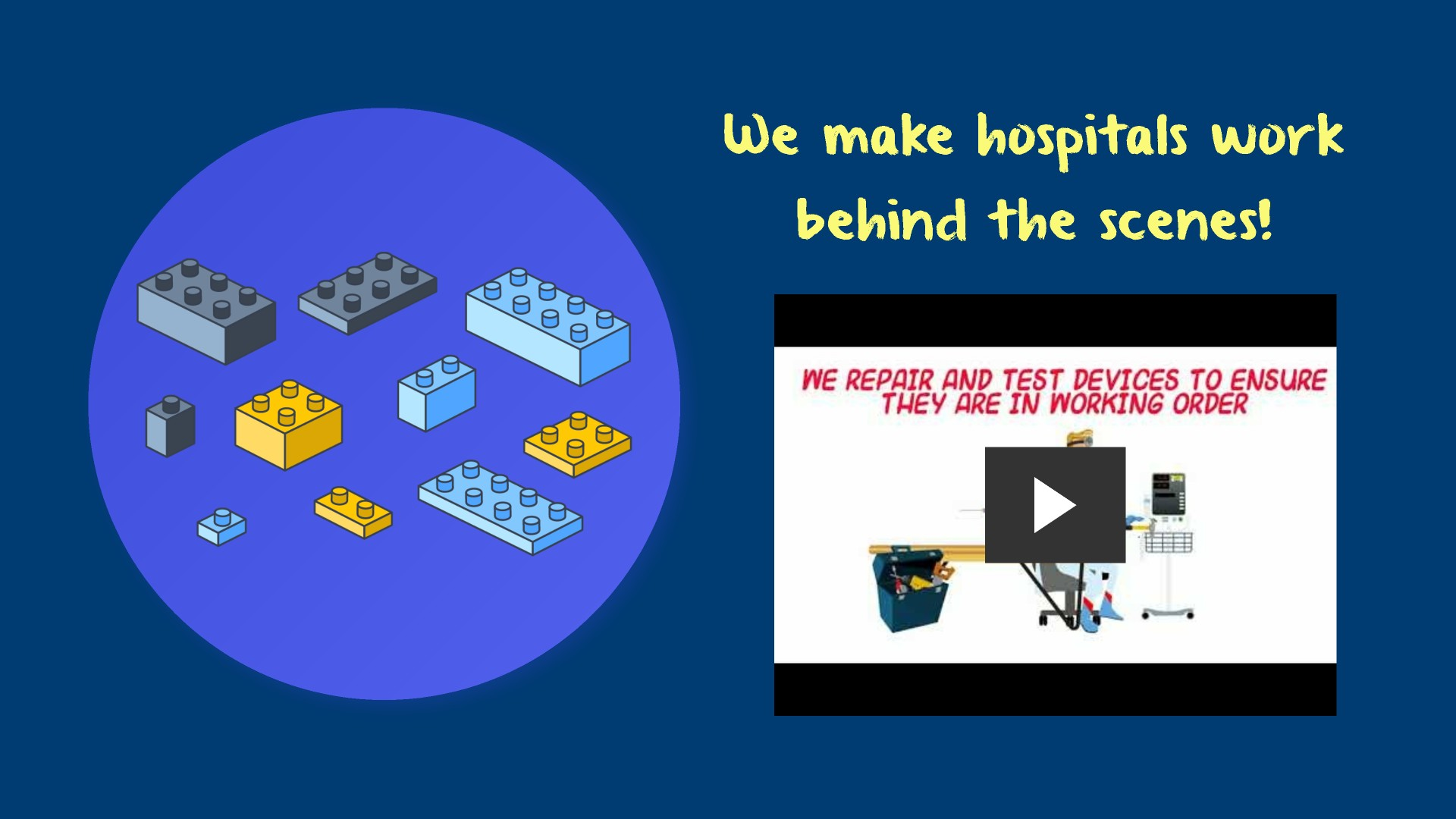

Notes:
- Give an example of a project you worked on that a child would find neat. (e.g. Working with Robotics, being involved in a construction project, picking out new equipment, installing new equipment, emergency situations, etc.).
- Take the time to explain the video and mention how the HTM professional comes to the rescue – like a superhero! Make sure to reiterate that this is what HTM professionals do all day long: solve problems that help patients.

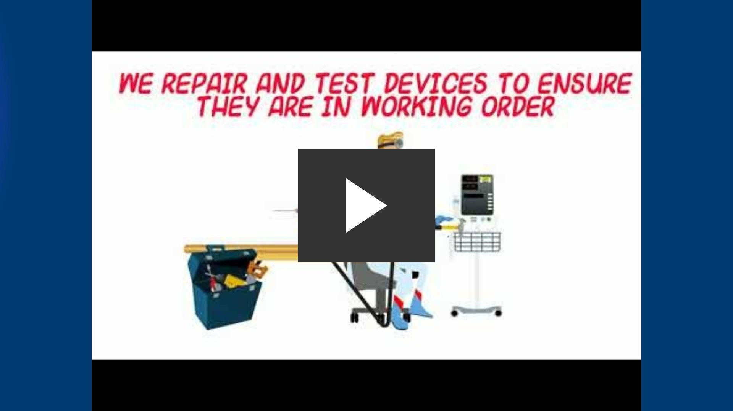

- Notes:
- Talk about all these attributes and mention how they relate to HTM and the work HTM Professionals do every day.

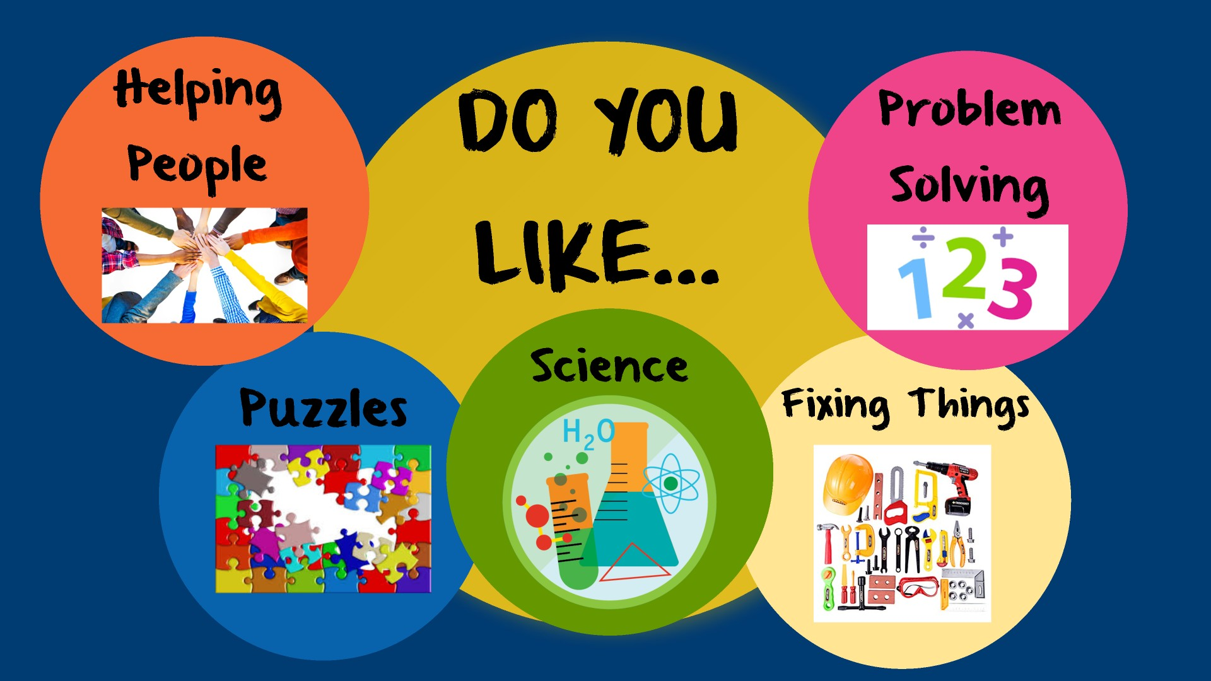
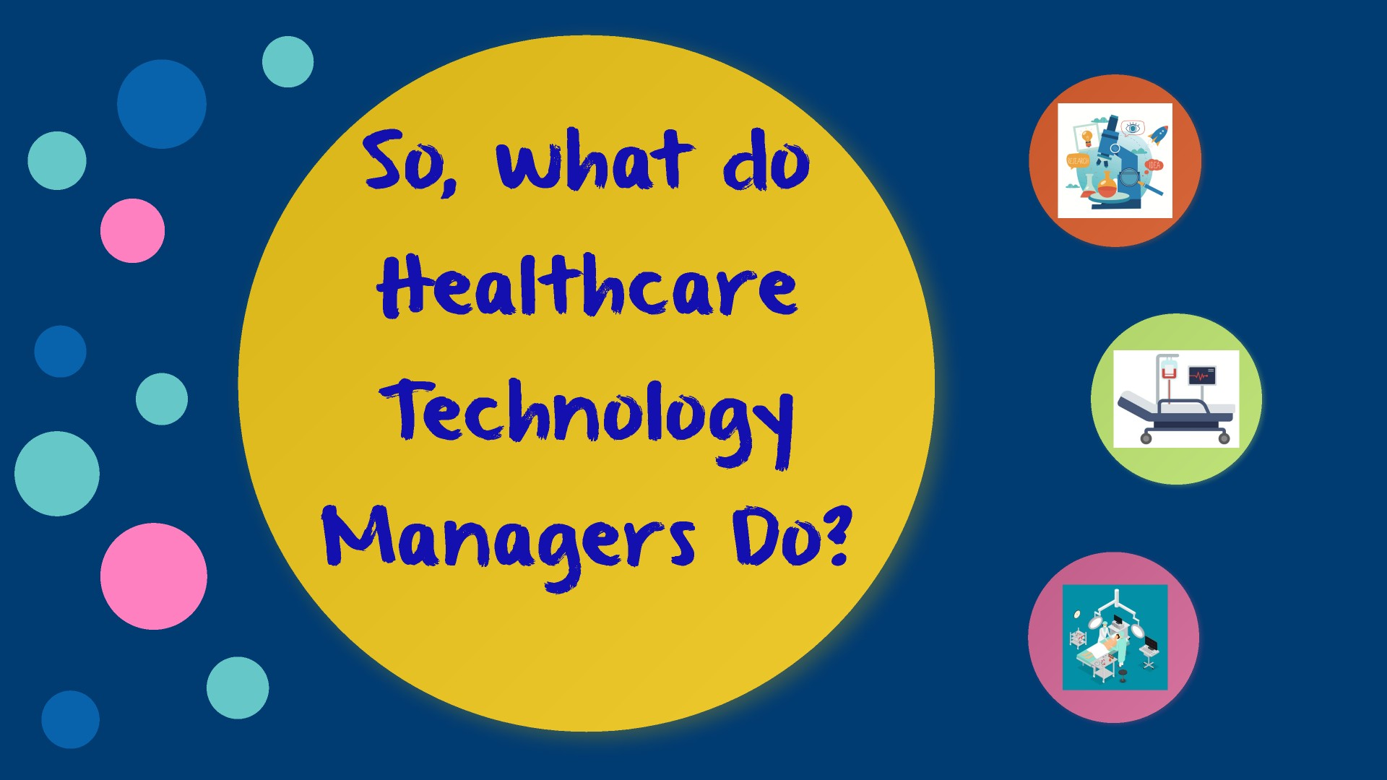

Notes:
- Ask this question to the audience and solicit answers before moving forward.

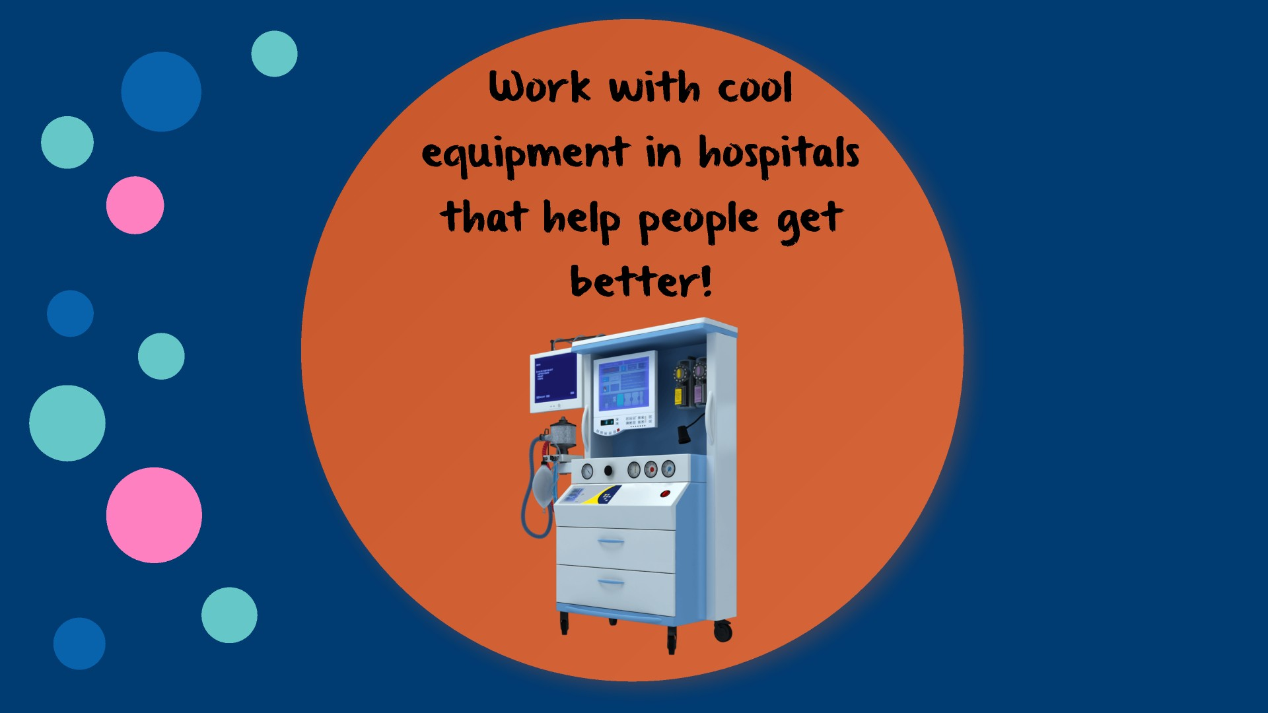

Notes:
- Give some age appropriate examples that the audience can relate to. Keep your tone upbeat and excited!
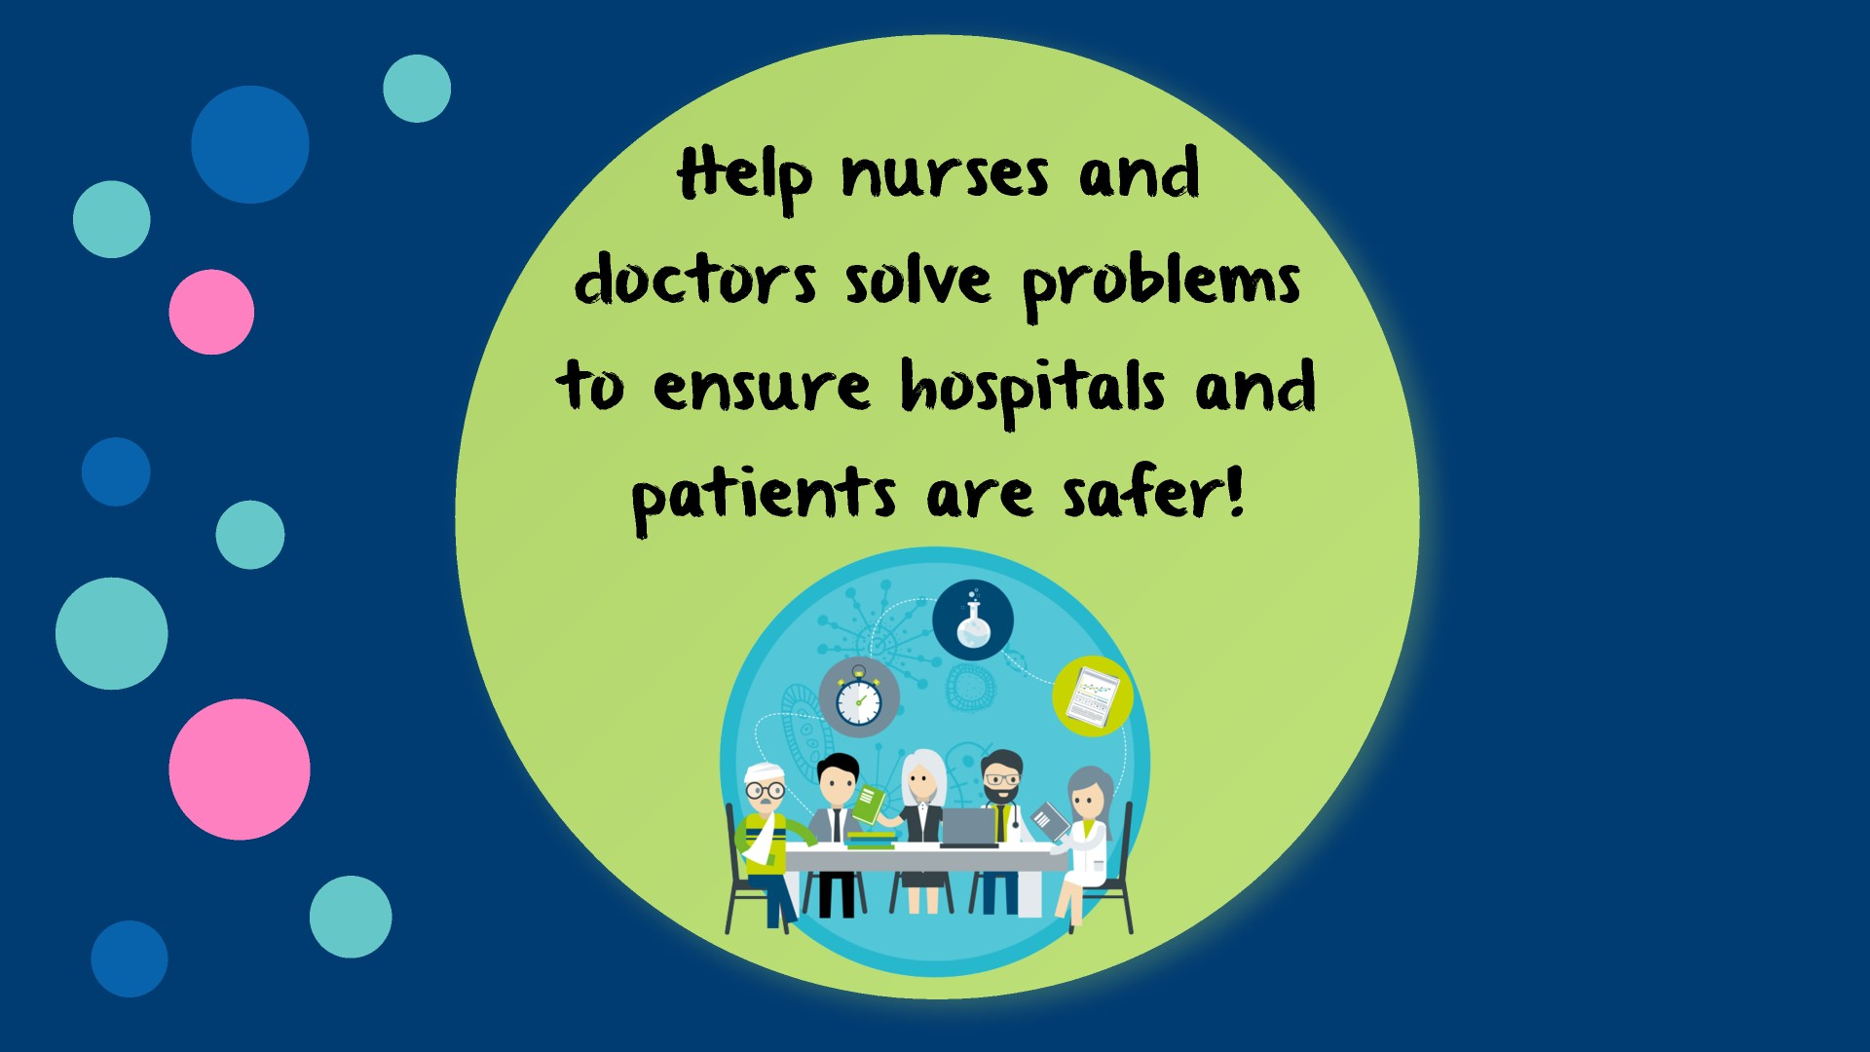

Notes:
- Give some age appropriate and simple examples that the audience can relate to.
- Or, tell a story about a meaningful interaction with a doctor, radiologist, surgeon, nurse or other staff person in the healthcare environment. Example: We worked with nursing to pick out a new fleet of patient beds. These beds are safer and have technology that help prevent patients from falling out of them. Patients get hurt from falling and because we helped with this project, less patients fall and get hurt. This allows them to go home to their families sooner.

Notes:
- Reiterate how much fun and exciting the job is. Share with the audience why you love what you do! Remember, excitement is contagious.

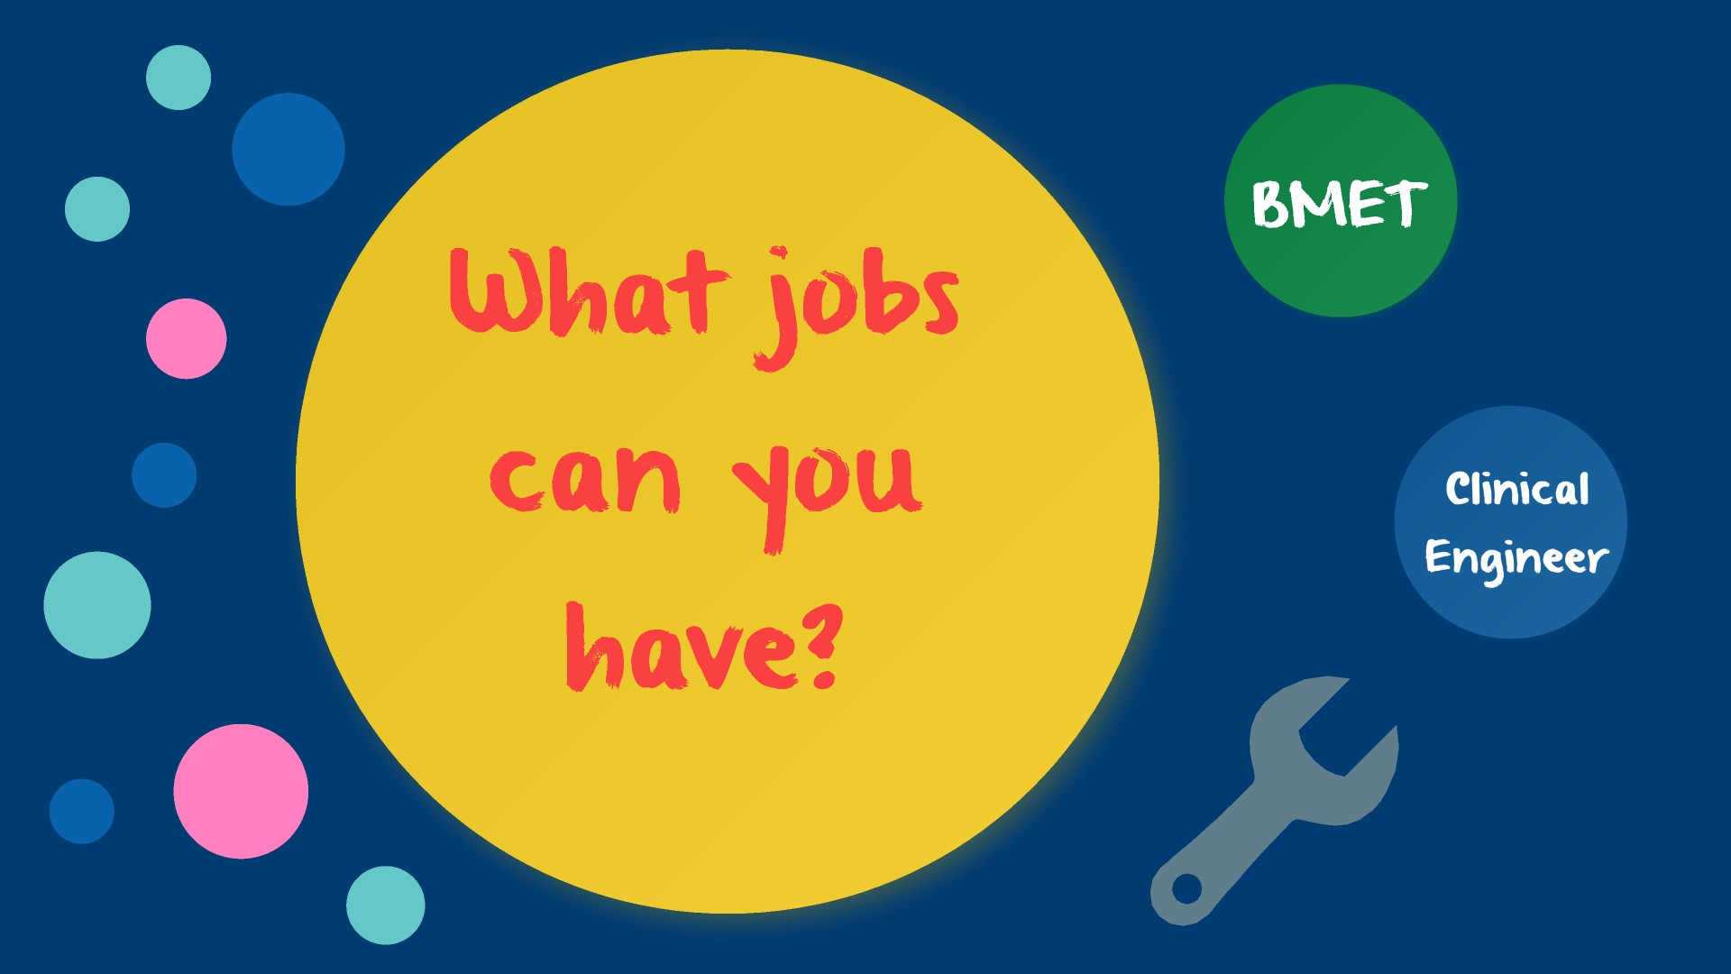

Notes:
- Have and know the job salary ranges for your area, in case you are asked. Only talk about salaries, if you are asked.
- Make sure the audience knows there is a difference in educational requirements for a BMET vs the Clinical Engineer.

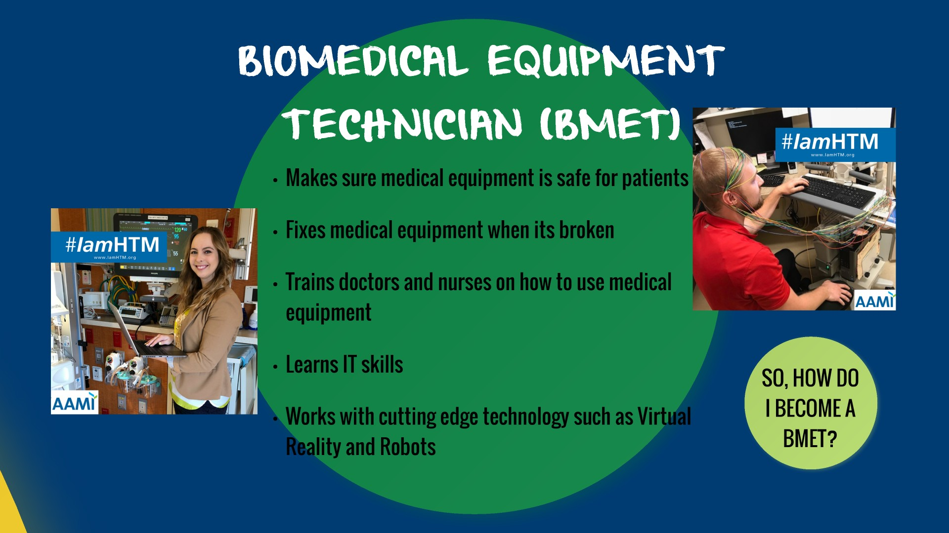

Notes:
- Make sure to stress that every day is different, and you learn something new every day.
- BMETs are the subject matter experts for the most cutting-edge technology in the hospital.

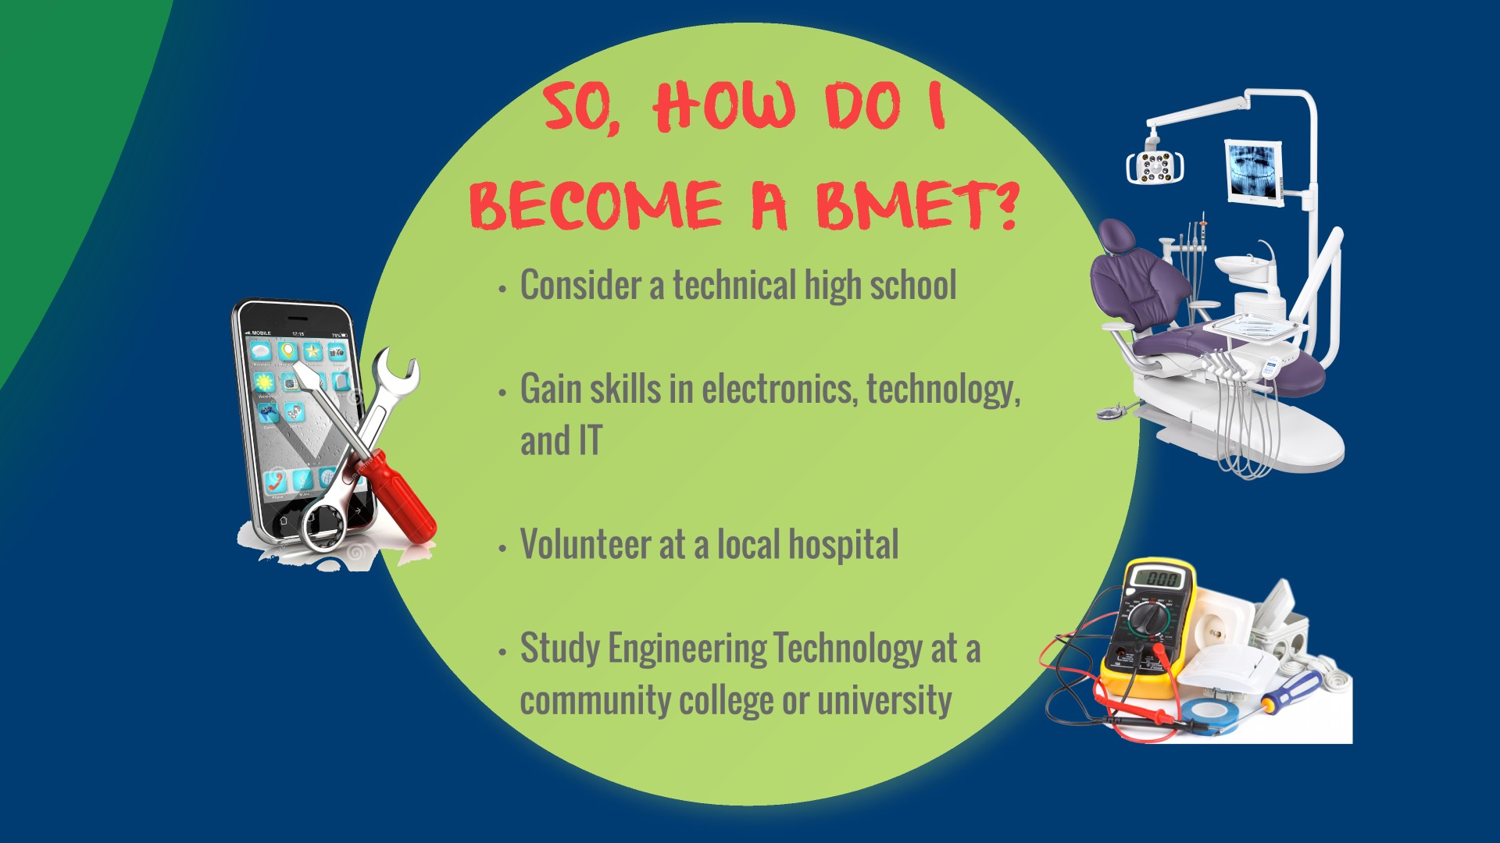

Notes:
- Know what technical/STEM schools (high schools and colleges) are local to the students.
- Know if the organization you work for has volunteer opportunities. Also, know all the local hospital’s in the area.

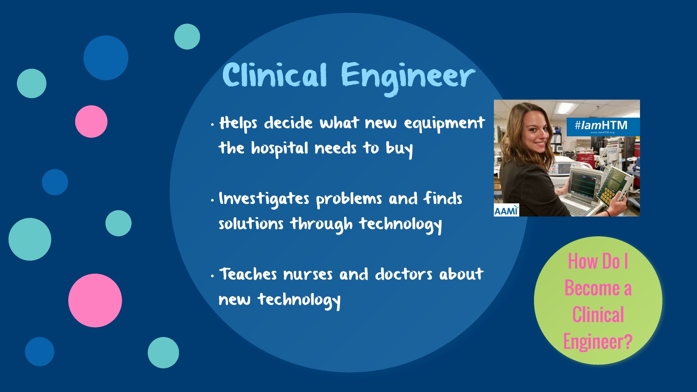

Notes:
- Reiterate that HTM Professionals solve problems to improve patient care and Clinical Engineers are always looking for new solutions to fix healthcare challenges.

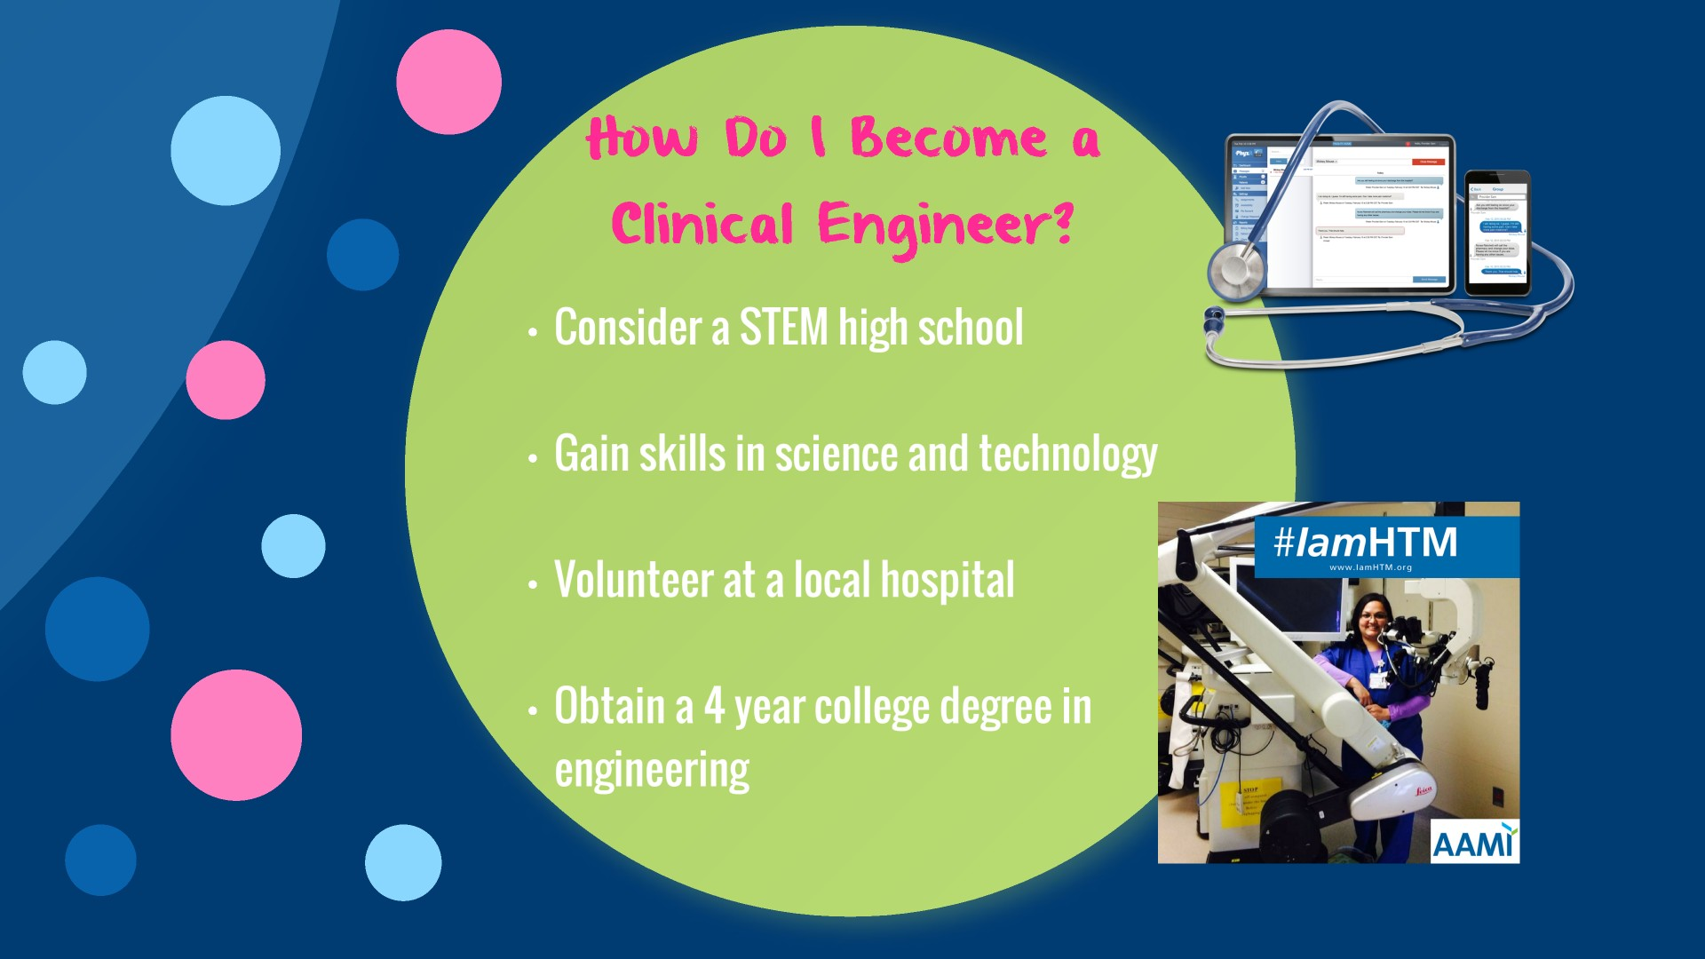

Notes:
- Know what technical/STEM schools (high schools and colleges) are local to the students.
- Know if the organization you work for has volunteer opportunities. Also, know all the local hospital’s in the area.
- Make sure you are clear that, in most cases, Clinical Engineers need an engineering degree.

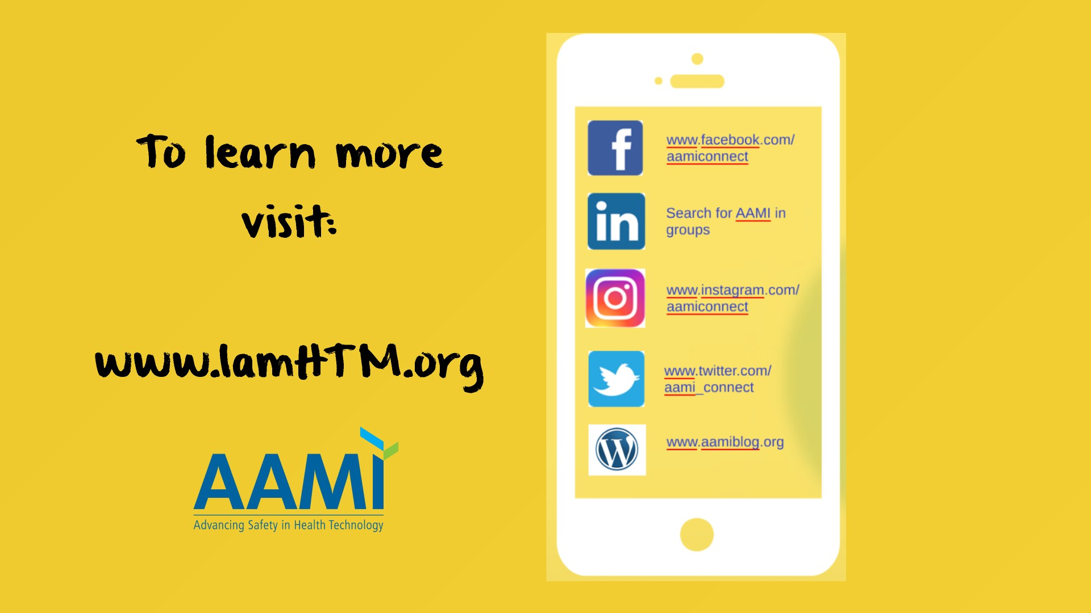

Notes:
- Emphasize that additional information about the field can be found at www.IamHTM.org.

High School Presentation

- Notes:
- This page should be used to introduce yourself. Once you have introduced yourself, you could say: “Today we are going to talk about Healthcare Technology Management and what an exciting career option it is!”
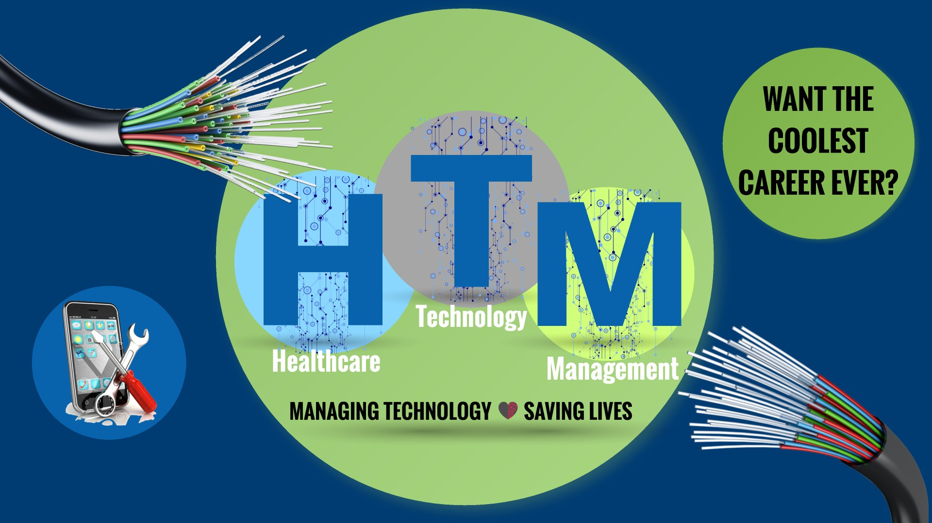

Notes:
- This presentation does not contain specific information about salaries. This information can be found in the adult (College and Beyond) presentation.

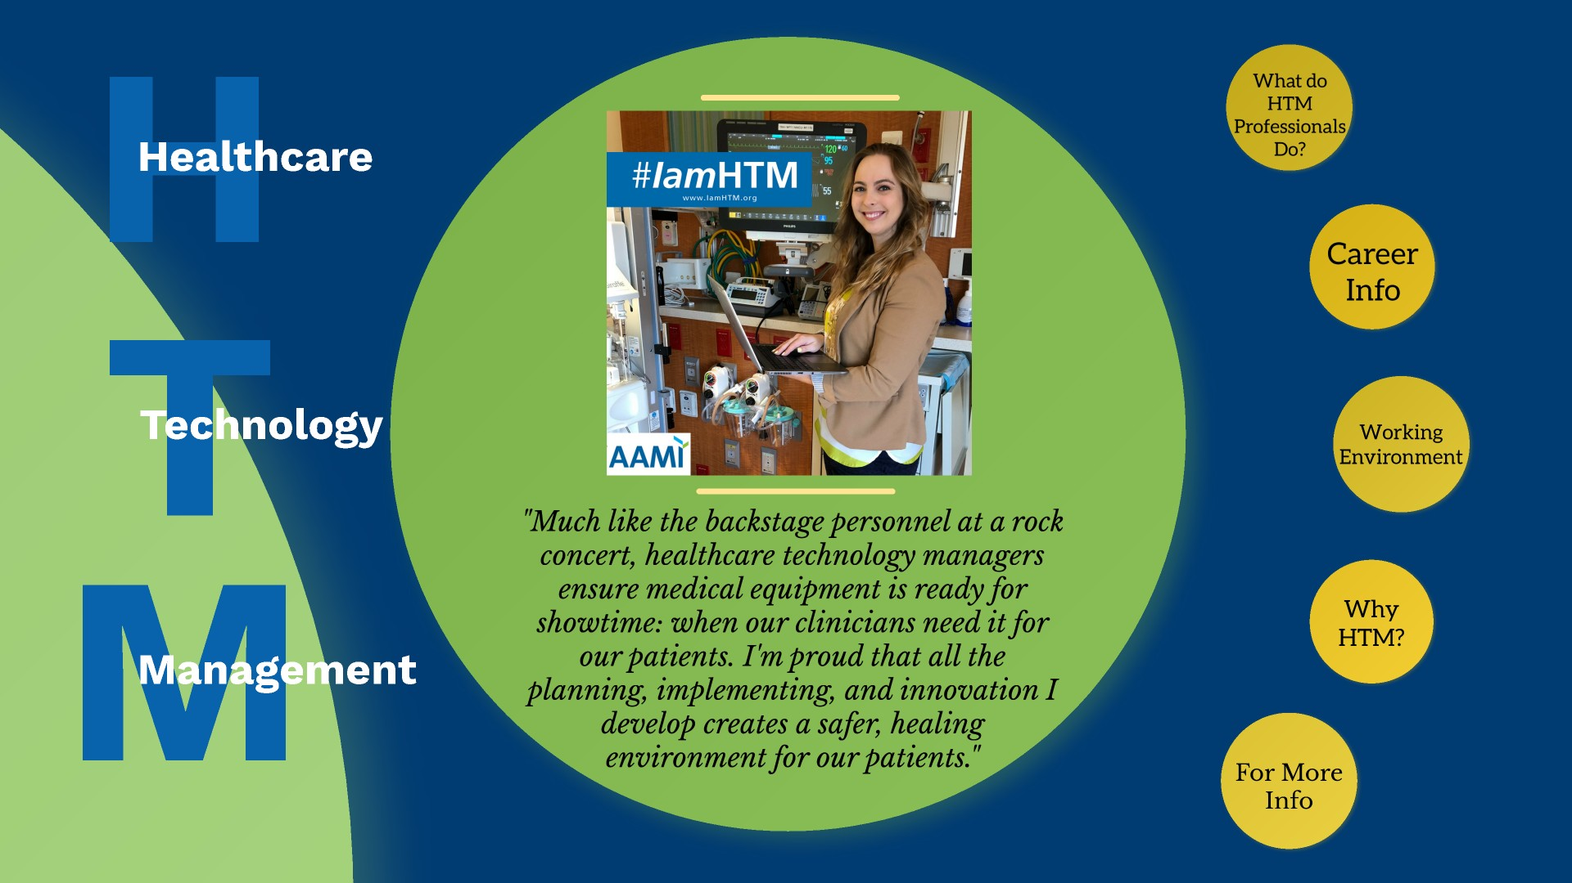

Notes:
- Make the correlation between how HTM is like being the backstage personnel at a rock concert to the audience and explain why.
- Ask the students if they have ever been to a hospital or doctor’s office and if they have ever thought about how all the medical equipment got where it is (who helped pick it out, who installed it, who tested it to make sure it works, how there conveniently is an electrical outlet right next to where the device was placed?)
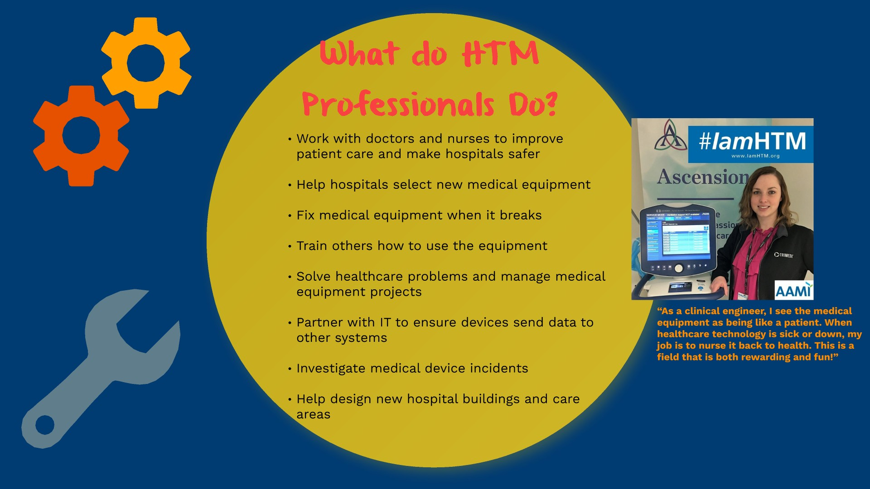

Notes:
- Make it personal and tell a story. Give some examples of projects you have been involved with.
- Talk about how much HTM professionals work with IT.
- Tell the audience that HTM Professionals basically make healthcare work behind the scenes.
- Mention the quote about how HTM professionals nurse the equipment back to health when its sick. Make a strong correlation for the audience.

Notes:
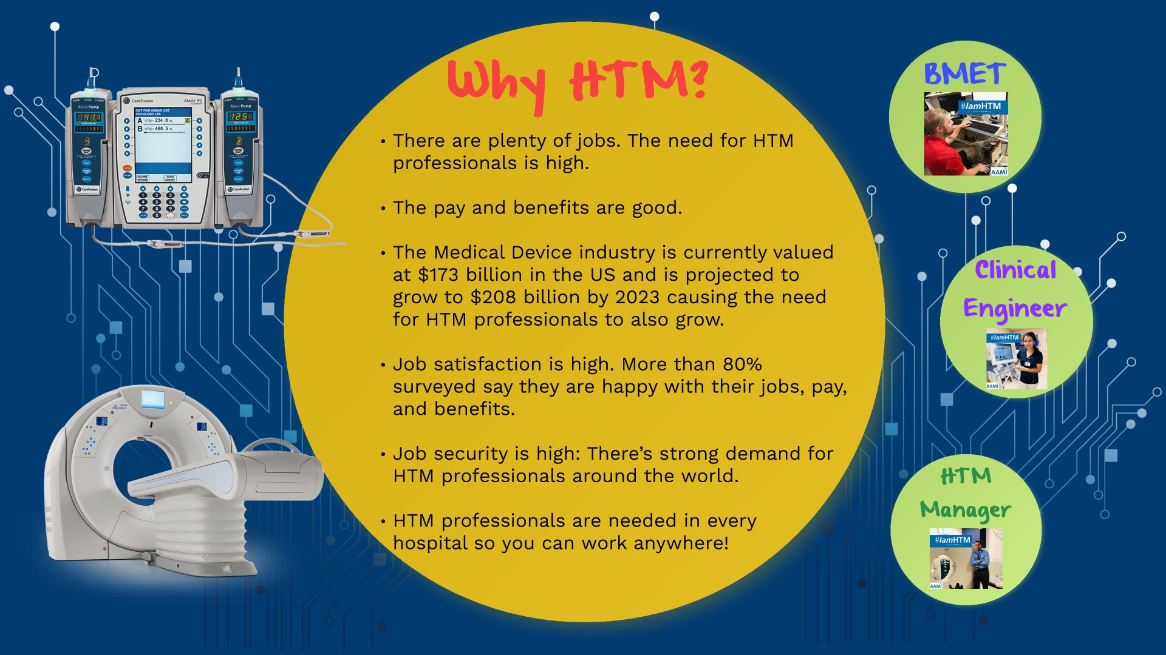
- This slide is a great place to tell the audience how your got into the field and why you love it so much.
- After telling your personal story, review the information on the slide.
- Be sure to reinforce that students WILL get a job out of school.
- Mention that there are HTM professionals in every hospital. This gives students the opportunity to stay in the town they grew up in or move anywhere in the country.
- Also mention that HTM professionals can be employed directly by the hospital, by a third-party repair organization or by medical device manufacturers. HTM professionals can obtain a job where they travel all over the country or a job where they go to the same hospital every day. The job options are endless.
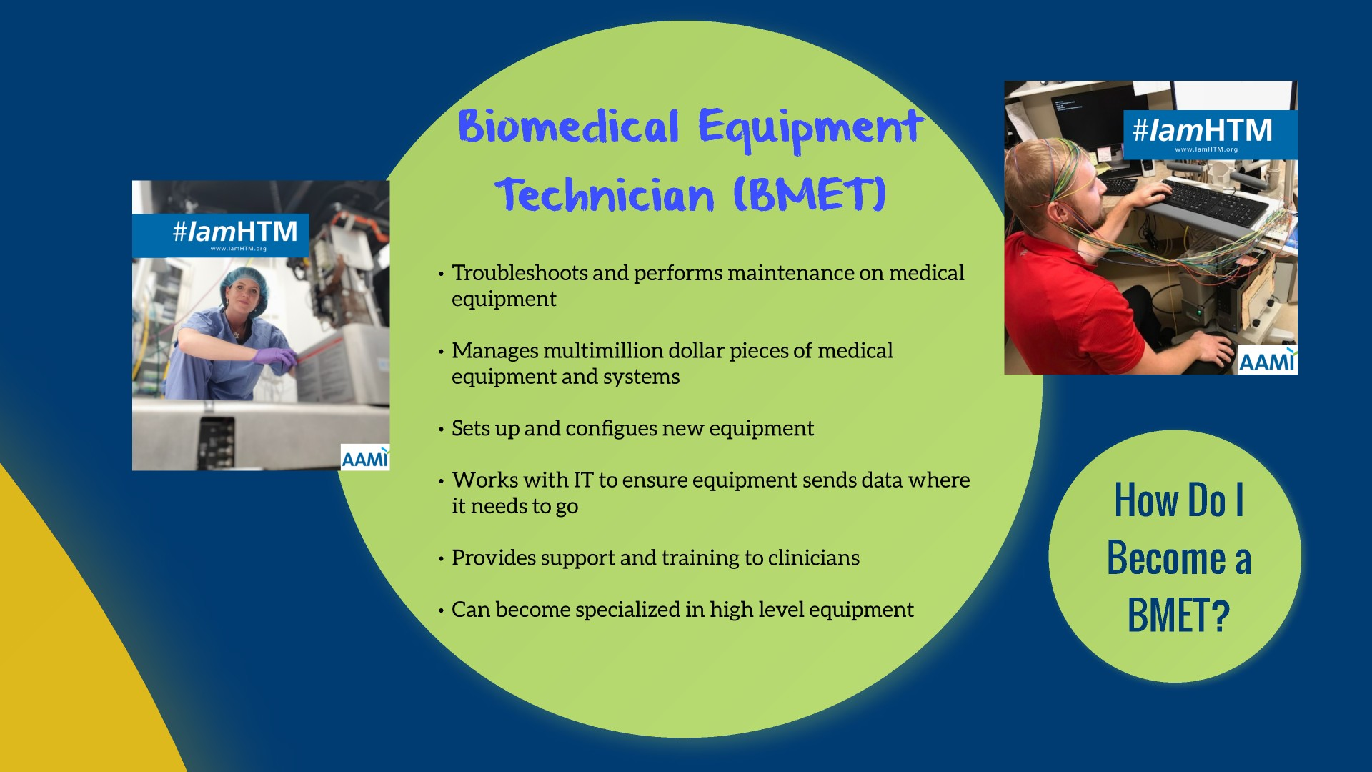

Notes:
- Talk through the slide and give short examples to better explain each bullet.
- Inform the audience that they will continue to learn and receive training on the job once they are hired. Learning does not end when school ends since medical technology is constantly changing. HTM professionals learn something new every day.
- As technology evolves so does the job of the BMET. HTM professionals will never be bored since the job is always changing.

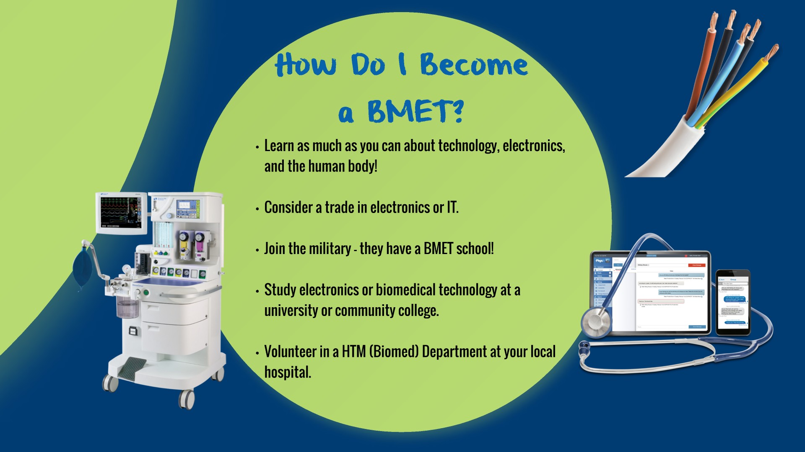
- ion or

Notes:
- Stress the importance of volunteering in an HTM department to start out.
- Explain that some hospitals call their HTM Departments: Clinical Engineering, Biomedical Engineering or Biomed when they call looking to volunteer.
- Have a list of local schools that offer BMET schooling available.

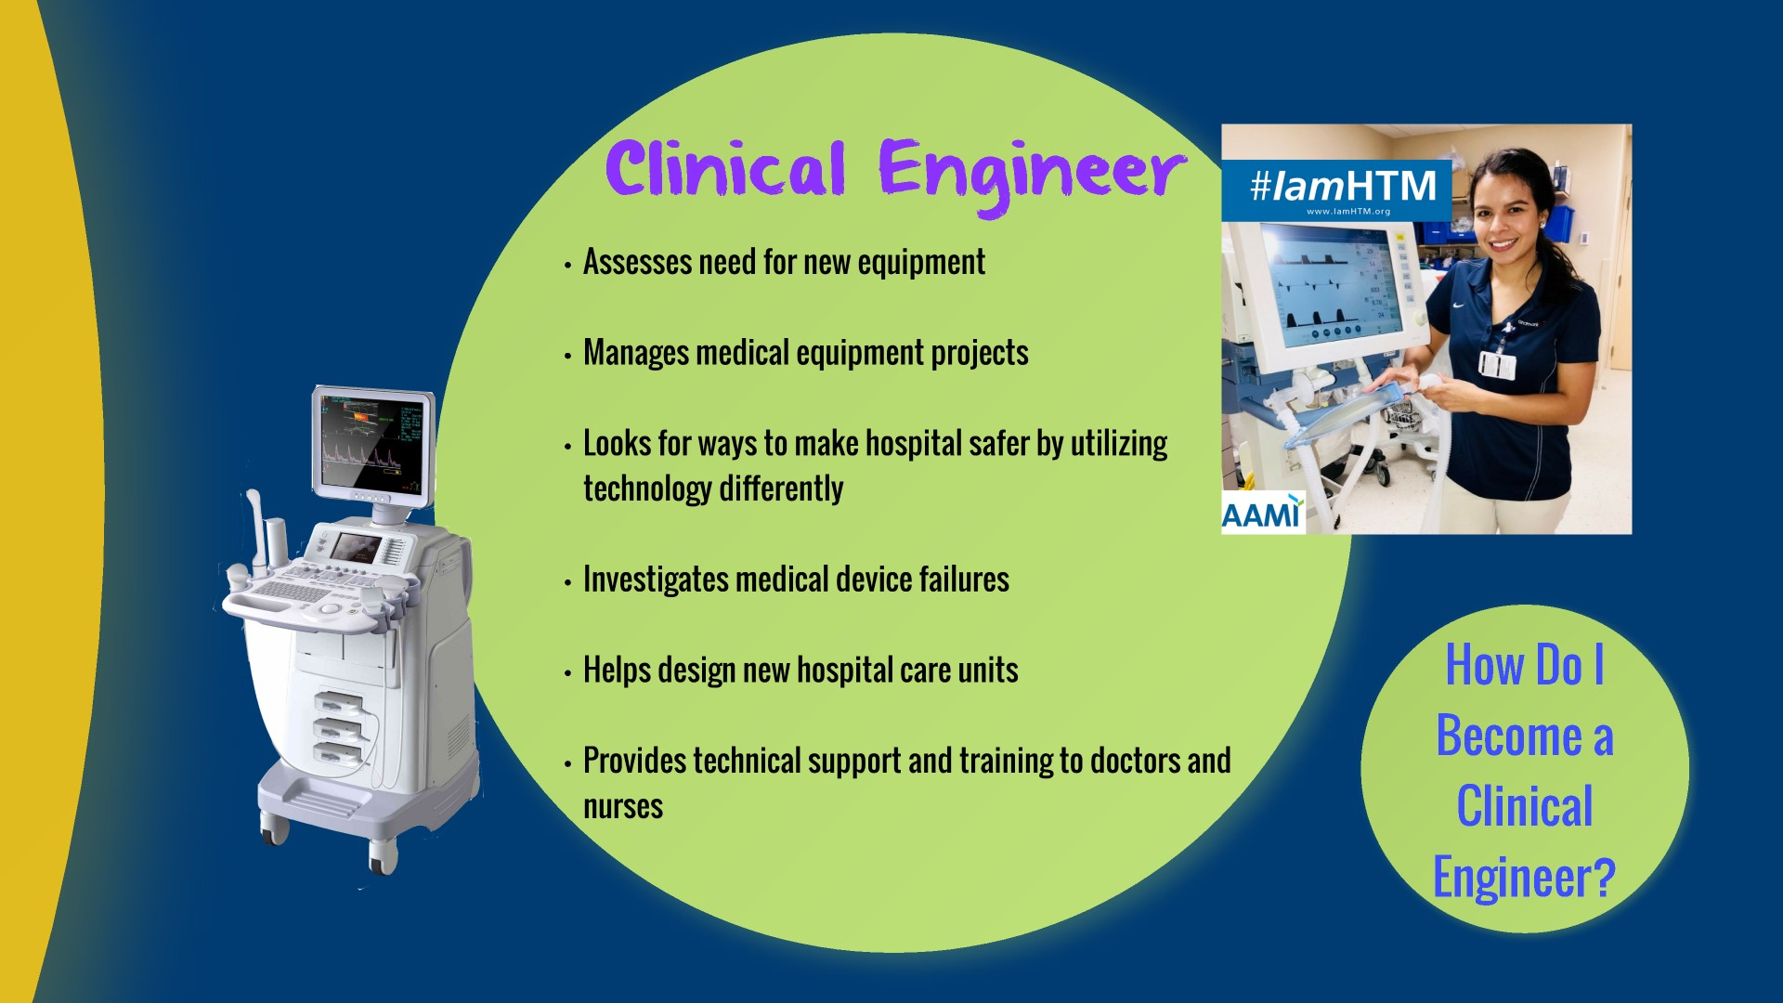

Notes:
- Give short examples to better explain each bullet point.
- Reiterate that you will continue to learn for the rest of your career. As hospitals acquire new technology, there will always be challenges to solve (eq: connecting a device to an existing system, cybersecurity, etc.).
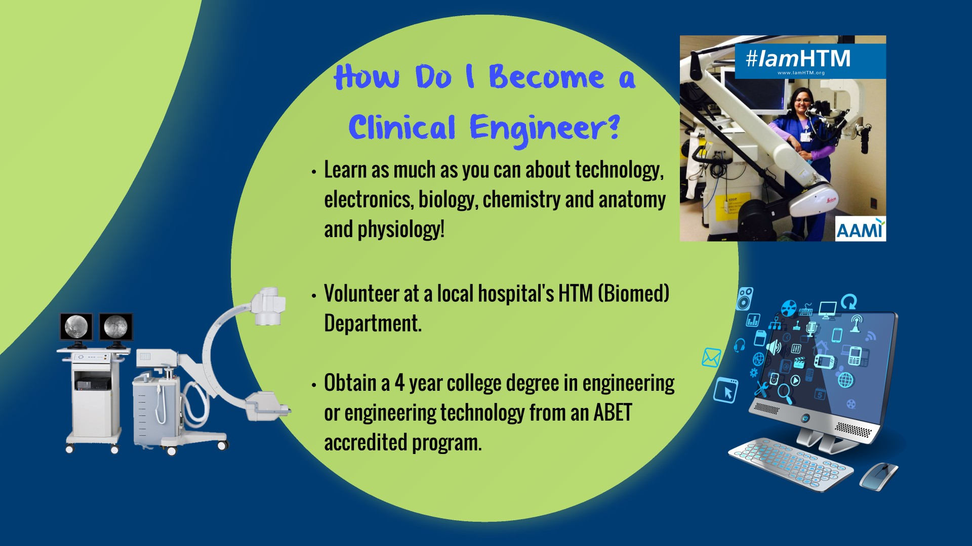

Notes:
- Stress the importance of volunteering in the HTM department as a start.
- Explain that some hospitals call their HTM Departments: Clinical Engineering, Biomedical Engineering or Biomed when they call looking to volunteer.
- Make sure to explain the different educational requirements for the Clinical Engineer vs the BMET. Clinical Engineers have an Engineering degree.

Notes:
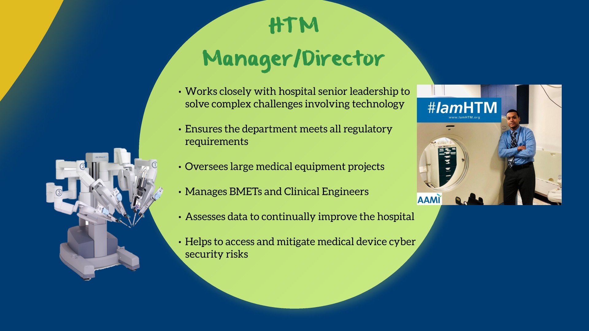
- This slide is meant to show students that the HTM career has an upward trajectory and growth potential.
- BMETs and Clinical Engineers can work their way up to run their own HTM Department.
- Continue to stress that HTM professionals work closely with hospital senior leadership/executives, IT, and clinical staff. (Avoid saying “c-suite” to this age group – high schoolers do not know what that means and often do not view hospitals as businesses)
- You can mention that some HTM professionals become VPs.

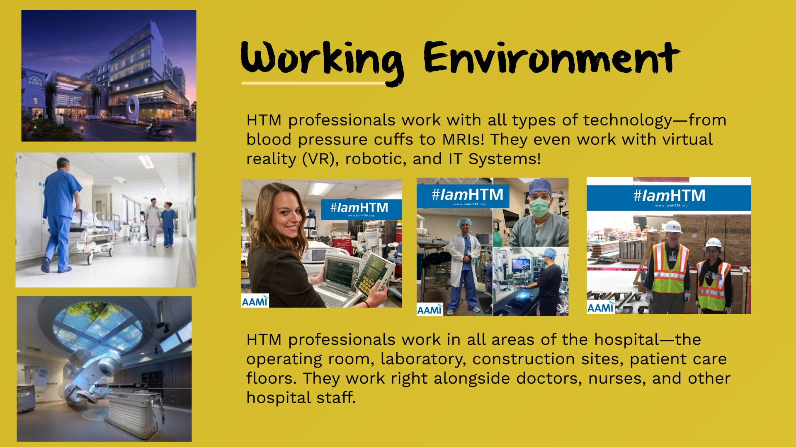

Notes:
- Mention all the places that HTM professionals can work in the hospital.
- Give examples of what HTM professionals do in each area. Don’t forget to mention construction projects as students may find that exciting.
- Mention all the different people and hospital staff you encounter every day.
- Also talk about the breath of technology HTM professionals support. Be sure to mention how that technology is changing to include robotics, Virtual Reality, and Artificial Intelligence.

Notes:
- Walk through this slide box by box – explaining each action and why it is important.
- Explain how unpredicatable your day can be and how no day is the same.
- Ensure the audience understands that whether you are a BMET, Clinical Engineer, or HTM Manager/Director, you will have a role in all these action items. Depending upon your position, your role you play in each issue will be different, but you will be involved in all these events.

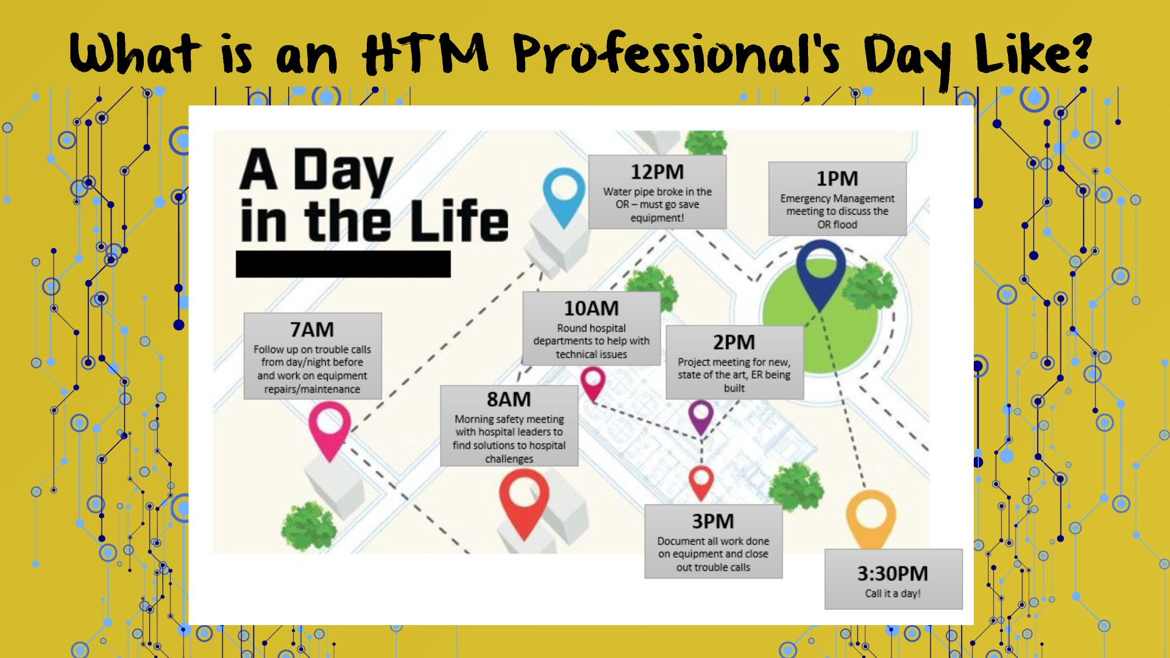

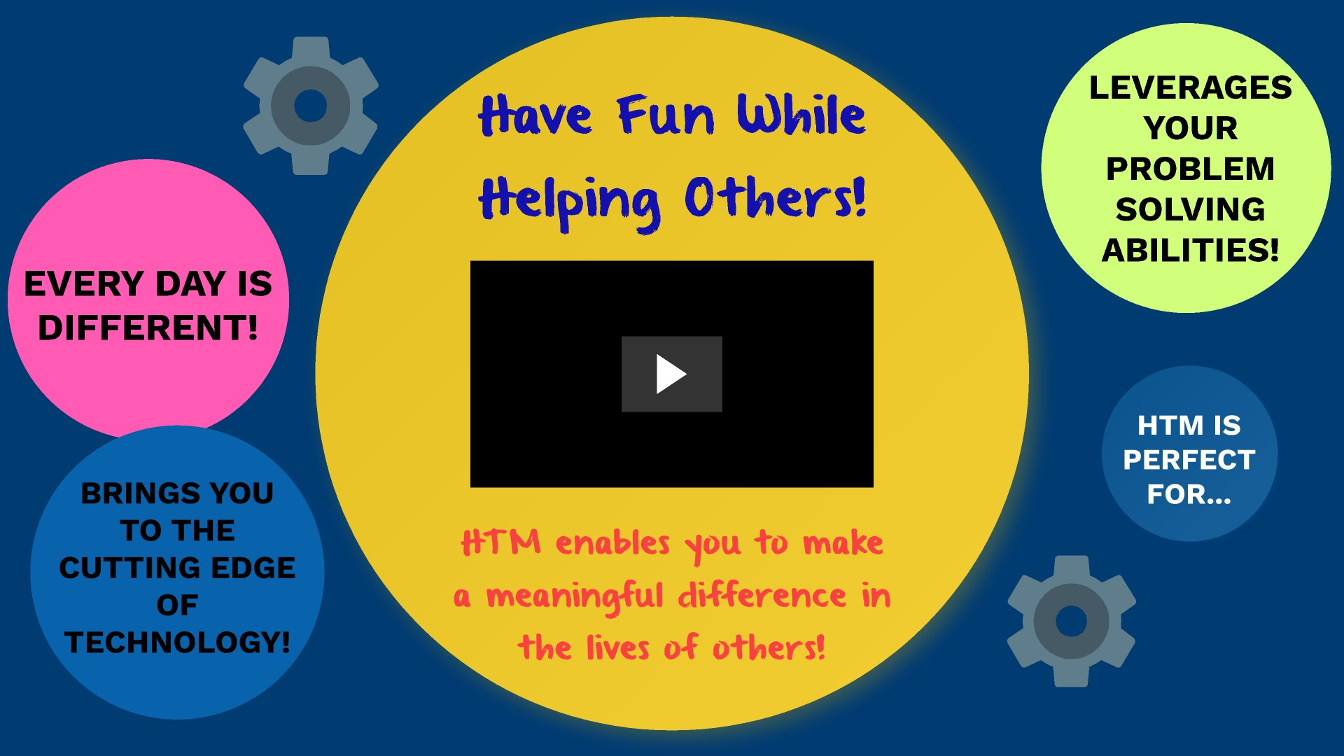

Notes:
- Tell the audience why you love HTM. Excitement is contagious. If you are sincerely excited about the profession, the audience will sense that.
- Stress how the career enables you to help others.
- Fun Fact: Mention that the video music track is made 100% of medical device sounds. Nothing was added in to supplement the track.

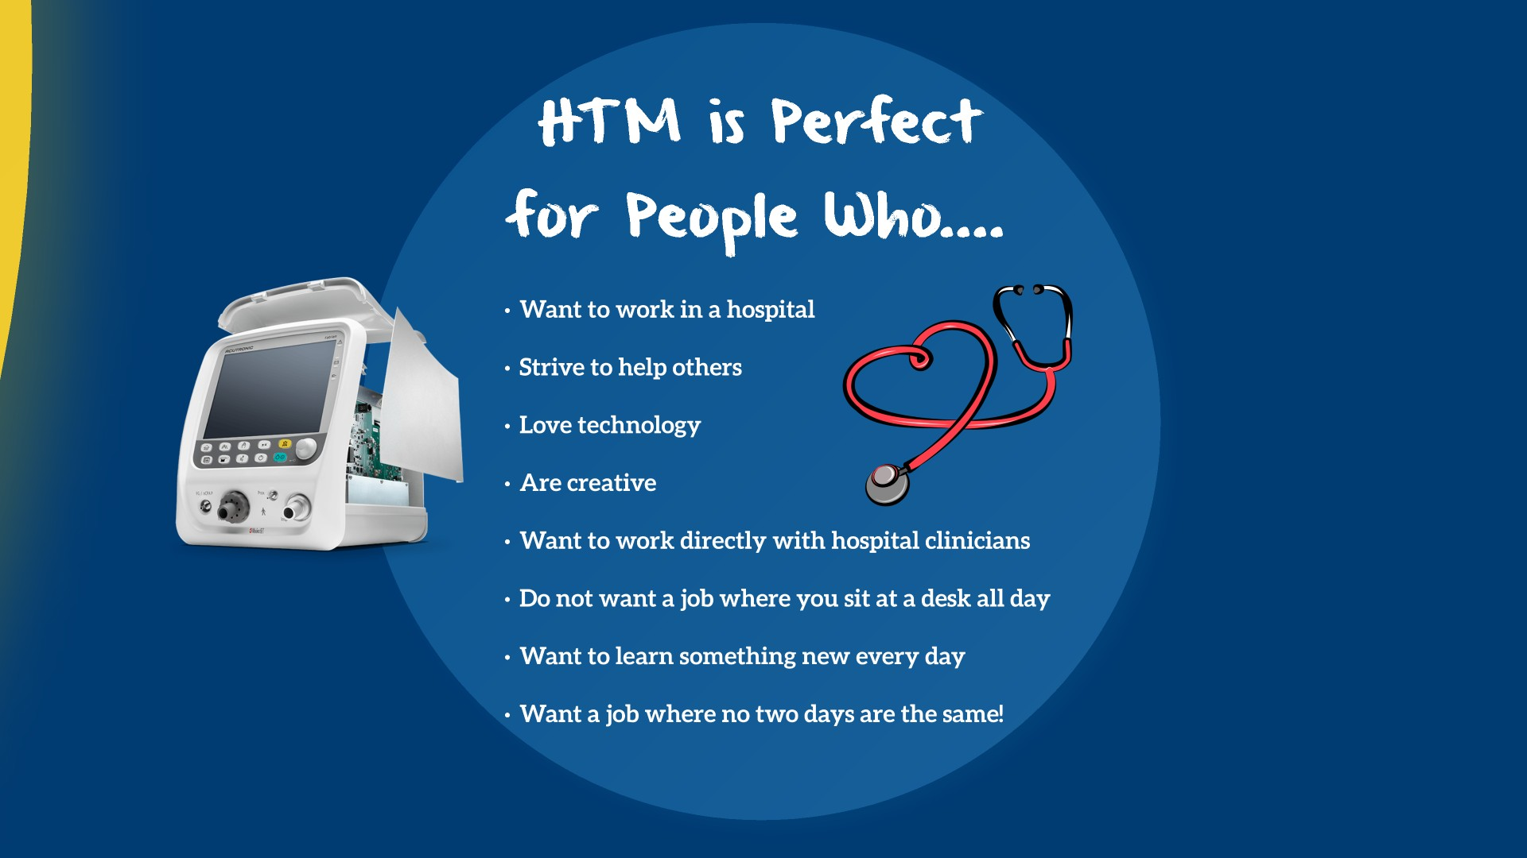
Notes:
- Stress all these points to the audience.
- The more excited you are about the career, the more excited the audience will be.

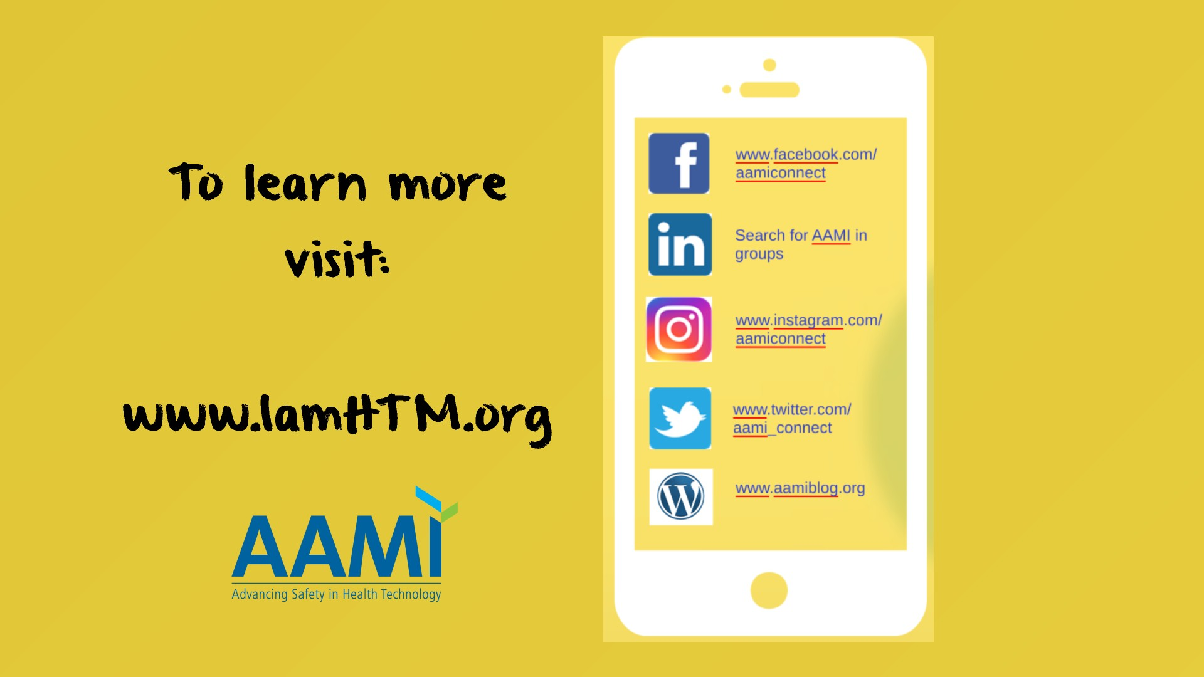

Notes:
- Emphasize that additional information about the field can be found at www.IamHTM.org
- Encourage students to follow AAMI and/or the hashtag #IamHTM on social media.

Adult/College Presentation
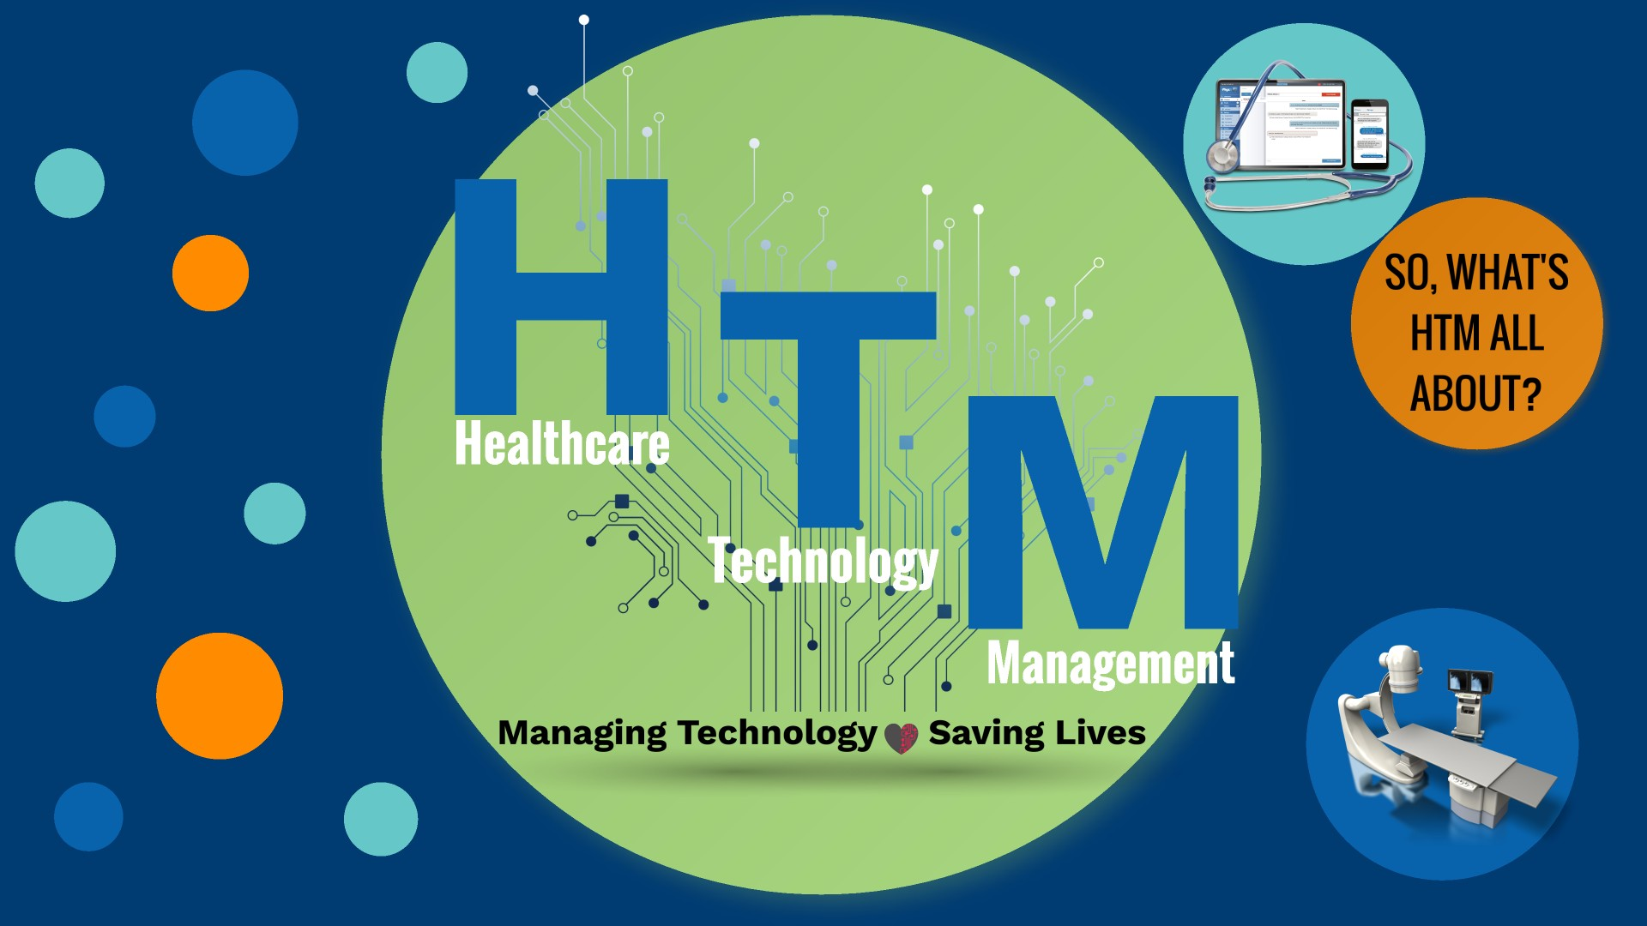

Notes:
- This presentation is very similar to the High School presentation. The major differences are that this presentation adds salary information into the occupation slides, has a “Related Careers and Degree” slide for potential career changes, and has a “Certification” slide to make listeners aware that the field offers certification options.
- For presentations at colleges: If you are speaking to a group of students in a general electronics program, you should spend much more time focusing on the BMET job role. If you are speaking to a group of engineering students, you should spend much more time on the Clinical Engineering job role. Tailor the presentation to fit your audience.

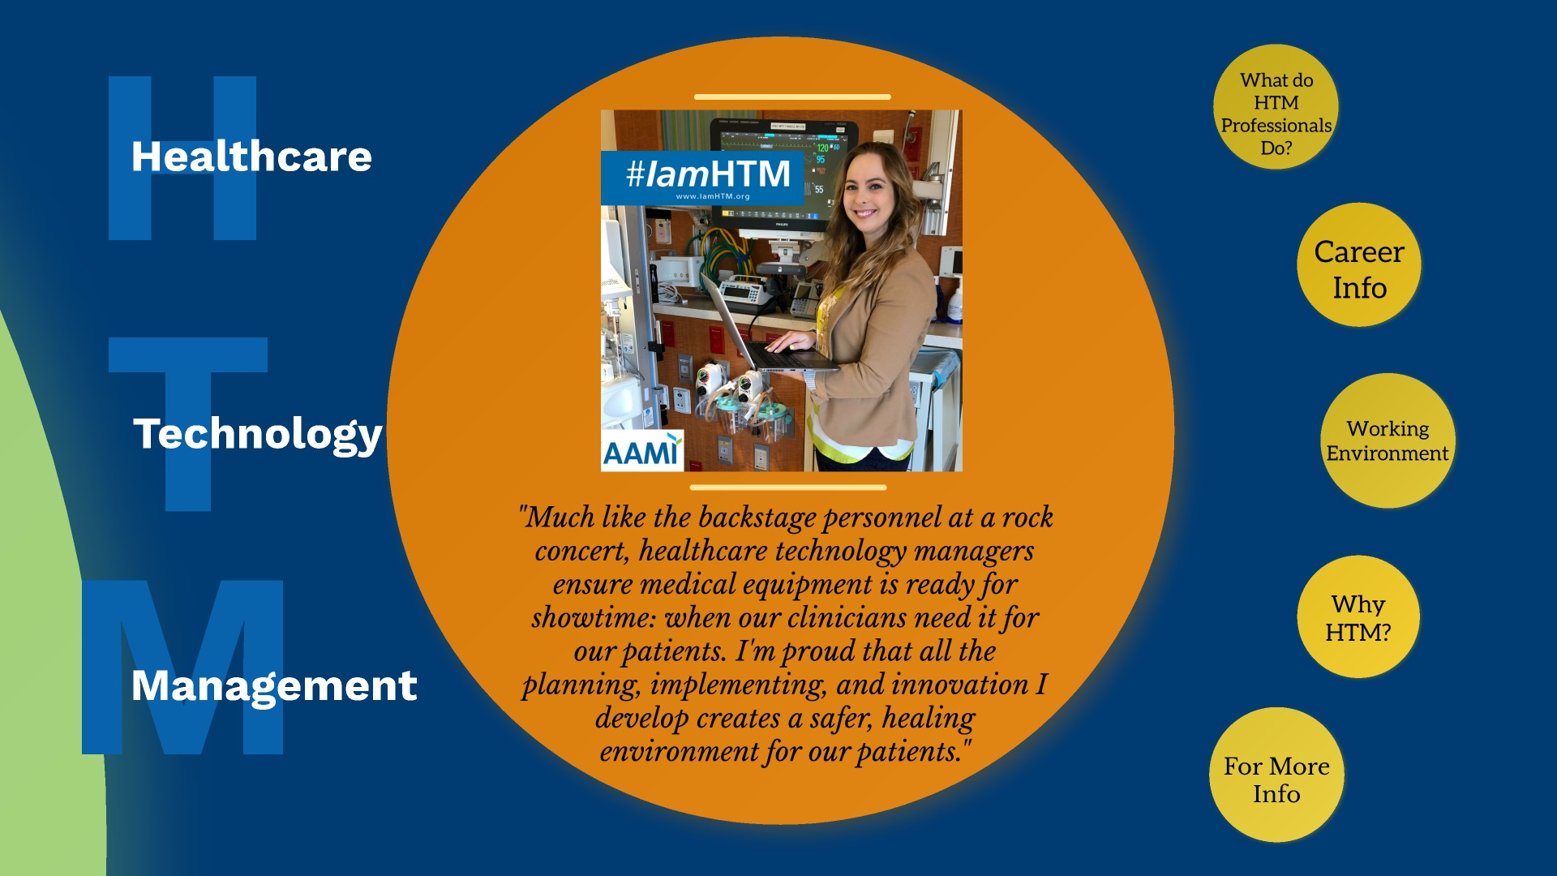

Notes:
- Make the correlation between how HTM is like being the backstage personnel at a rock concert and explain why.
- Ask the students if they have ever been to a hospital or doctor’s office and if they have ever thought about how all the medical equipment got where it is ( who helped pick it out, who installed it, who tested it to make sure it is working, who trained the clinicians how to use it, how an electrical outlet was placed right next to the device, how the equipment sends patient information back to electronic health record).
- It is also worth mentioning that the field is sometimes referred to as Biomed or Clinical Engineering within the hospital to ensure the audience understands it is all the same career.
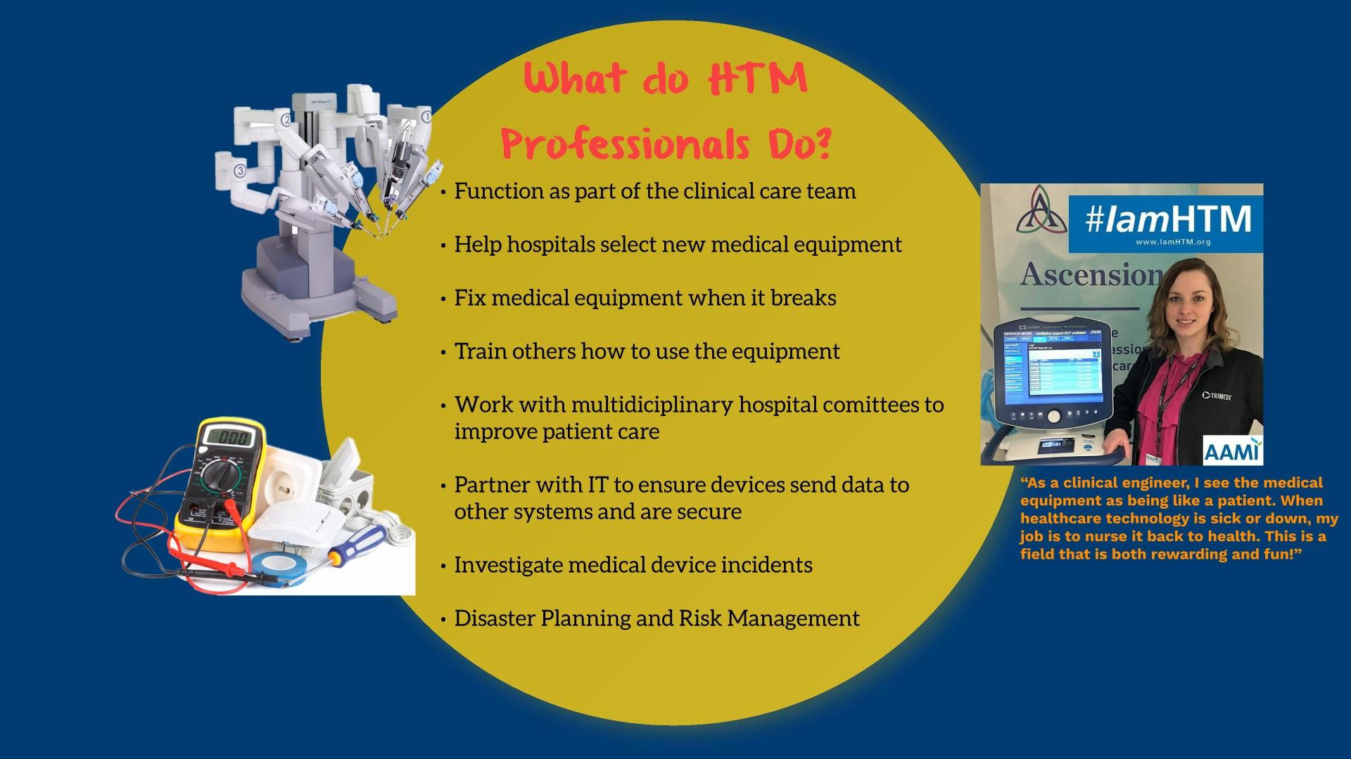

Notes:
- Make it personal. Give some examples of projects you have been involved with.
- Talk about how much HTM professionals work with IT.
- Tell the audience that HTM Professionals basically make healthcare work behind the scenes.
- Mention the quote about how HTM professionals nurse the equipment back to health when its sick – make the correlation back to healthcare.
- Point out the disaster planning and risk management part of the job and give examples of how HIM professionals get involved in these initiatives.
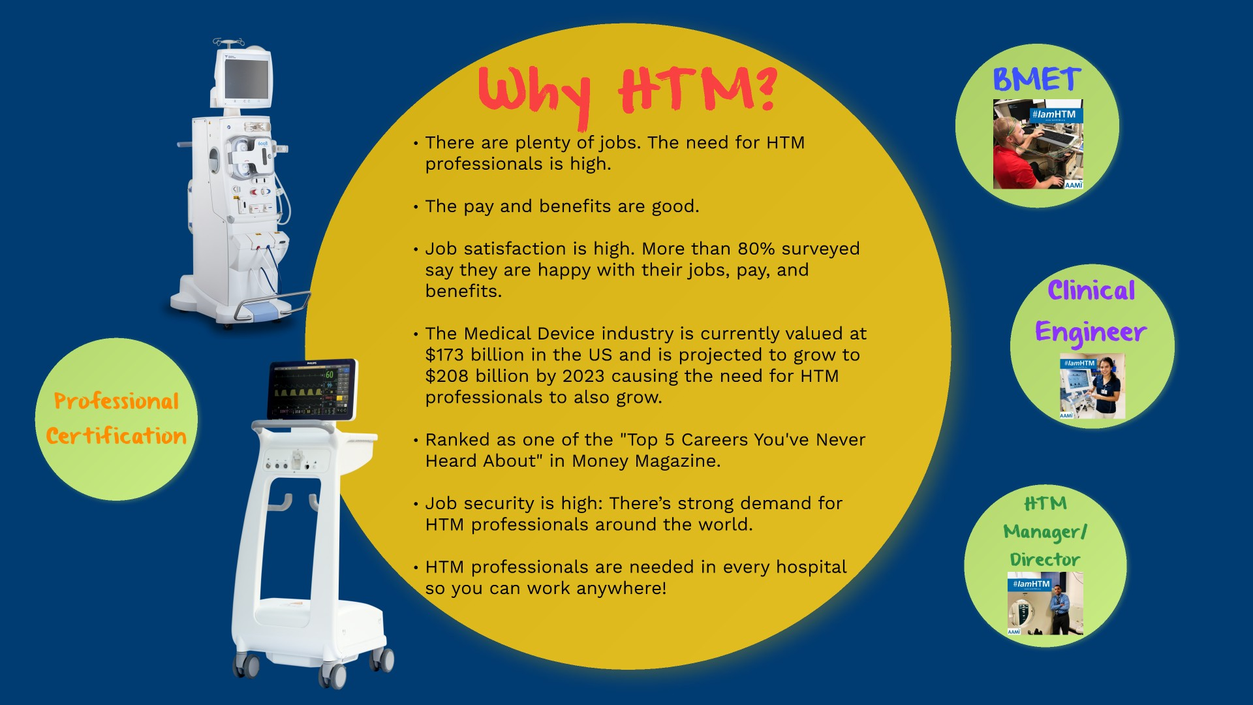

Notes:
- This slide is a great place to tell the audience why you love HTM so much. Make your story personal and heartfelt.
- After telling your personal story, review the information on the slide.
- Be sure to reinforce that there are lots of jobs available and they WILL get a job out of school.
- Mention that there are HTM professionals in every hospital so there are plenty of jobs. Point out that you can stay in the town you grew up in or move anywhere in the country. There are also jobs available where you can travel all over the country and world.
- Also mention that HTM professionals can be employed directly by the hospital, by a third-party repair organization or by medical device manufacturer.
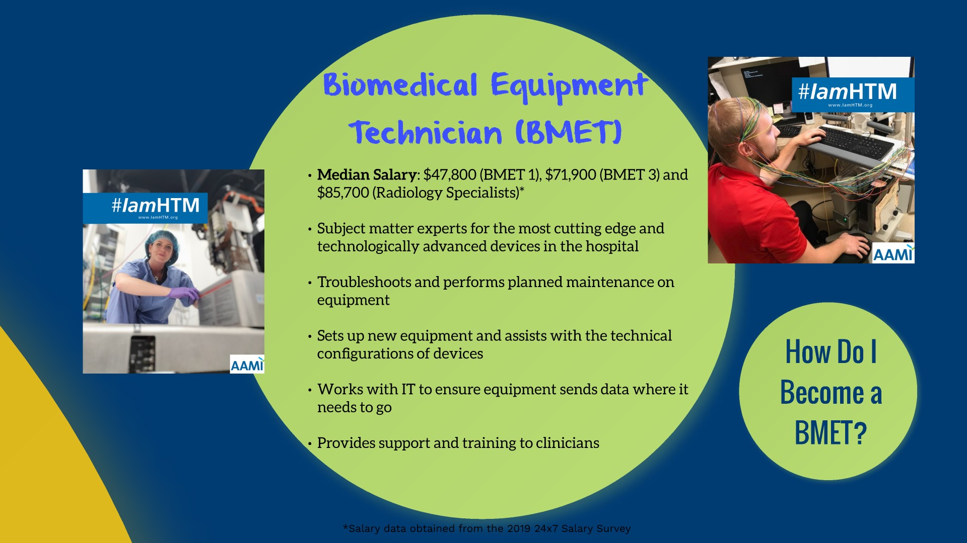

Notes:
- The salaries listed are the median salaries for the entire US. You may want to have more specific salaries prepared for your geographical area.
- Talk through the slide and give short examples to better explain each bullet.
- Inform the audience that you will continue to learn and receive training on the job. It is important to stress that learning does not end when school ends. HTM Professionals are constantly learning about new technology and technology is always changing.
- As technology evolves so does the job of the BMET. BMETs are the subject matter experts for some of the most expensive and complex technologies in the hospital. You will never be bored!
- It is also worth noting that BMETs can also be field service based where they cover a territory and are a specialist for one modality/device. These BMETs get to visit lots of different hospitals.
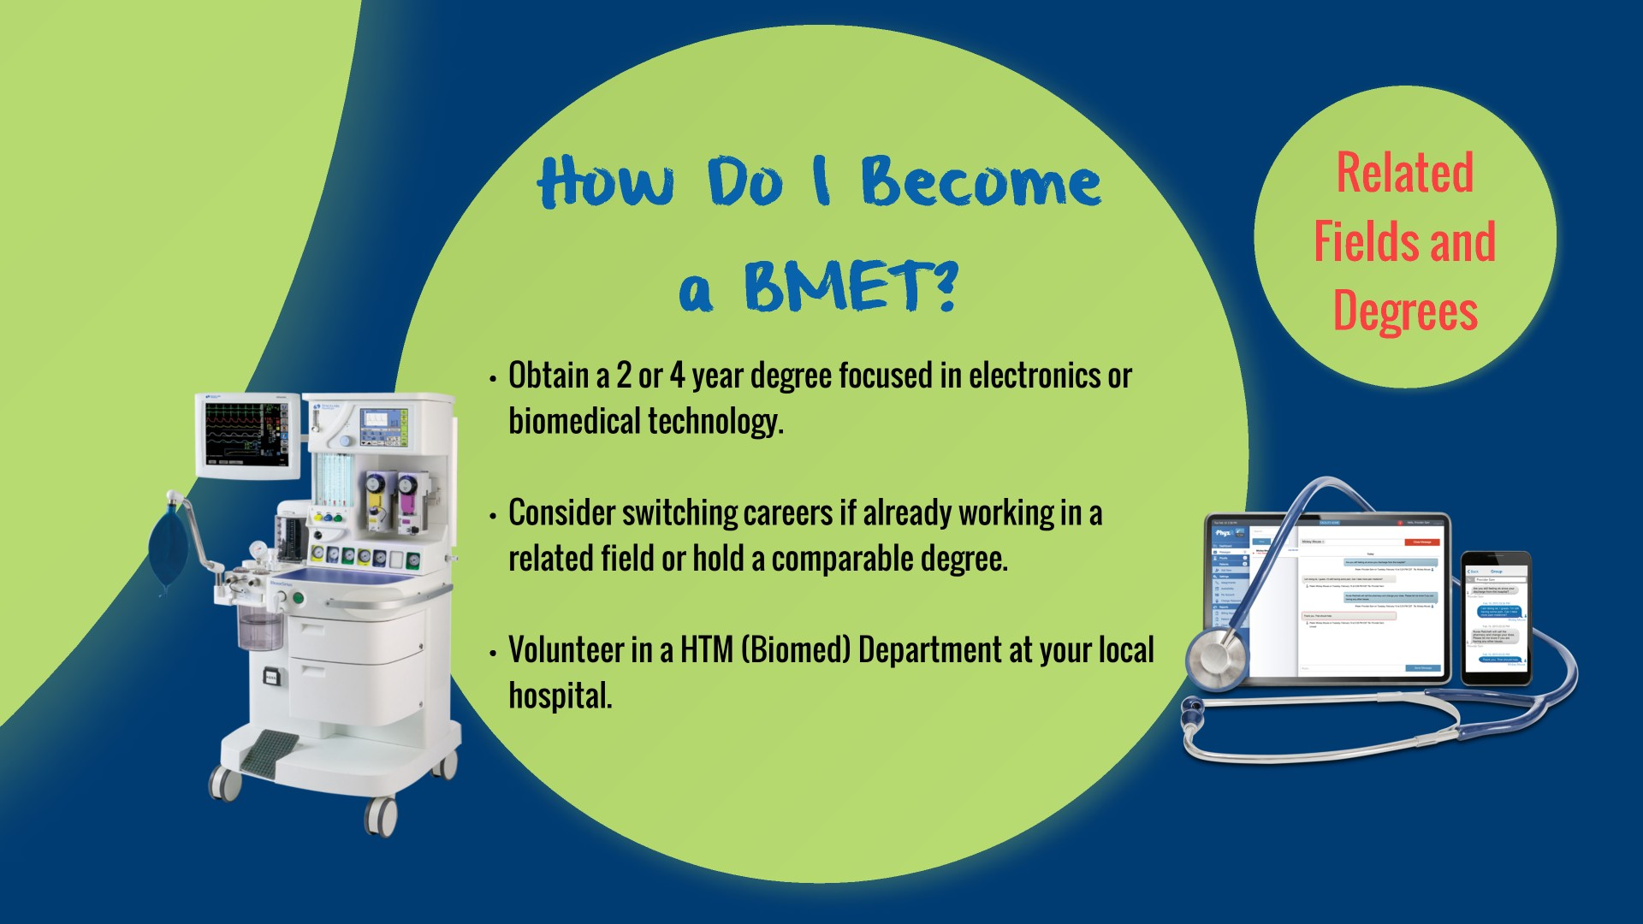

Notes:
- This is our time to convince students that HTM is the career option they want to choose, if they are studying general electronics. If they are in a general program, tell him how to find a career in HTM.
- If the audience is in school or a group of career changers, stress the importance of volunteering in the HTM department as an entry point into the field.
- Explain that some hospitals call their HTM Departments: Clinical Engineering, Biomedical Engineering or Biomed when they call looking to volunteer.
- Have a list of local schools that offer BMET schooling available in case anyone is looking to go back to school or switch degrees.
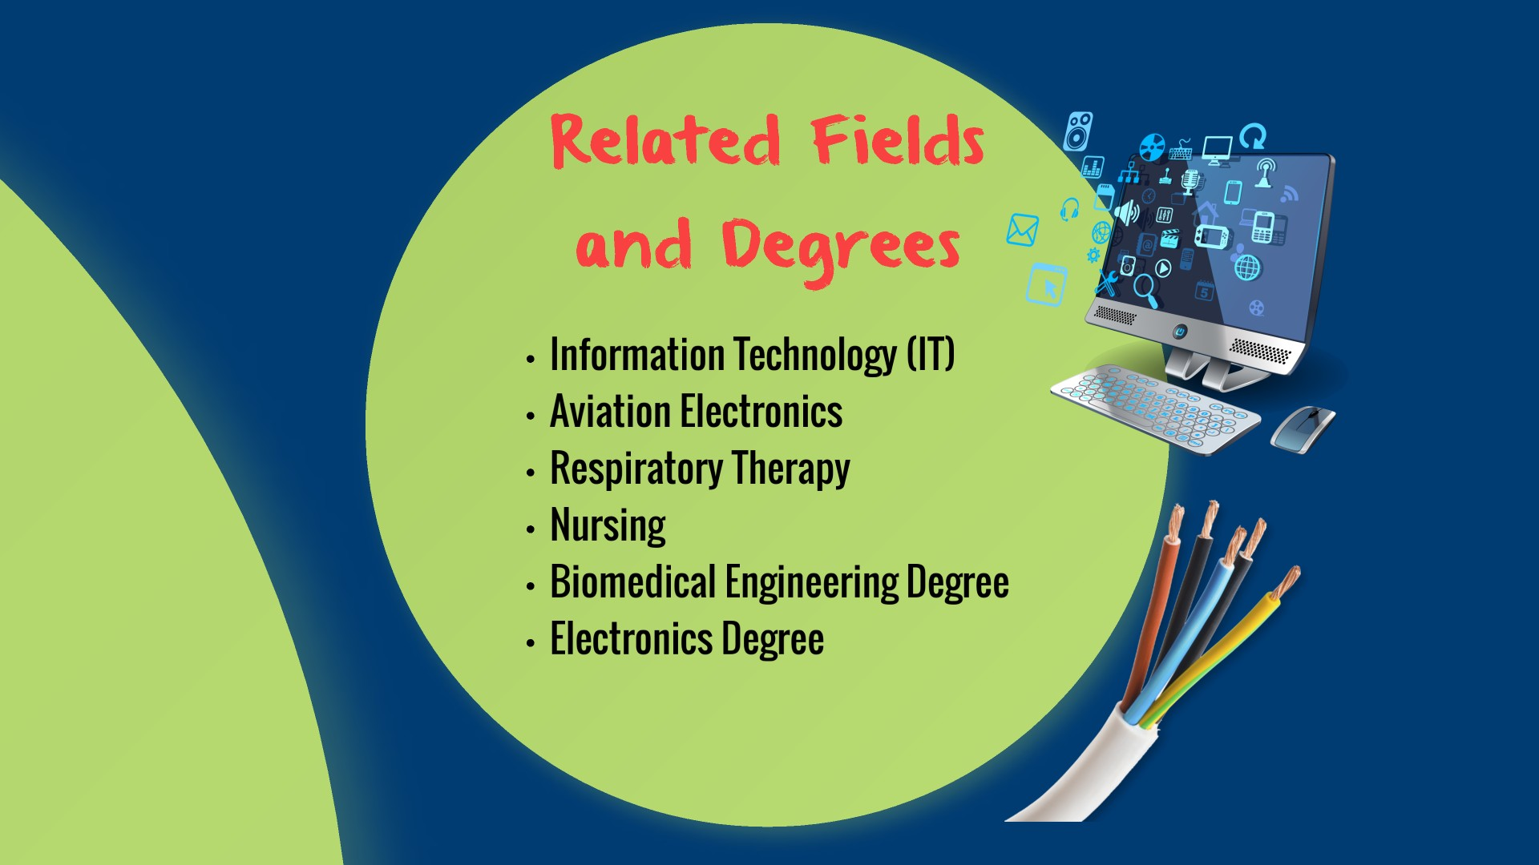

Notes:
- This slide is meant to appeal to career changers or students current enrolled in one of these programs to show the parallel.
- It is important to ensure the audience realizes that HTM professionals need a mix of skills and there in not just one path or entry point to get into the field.
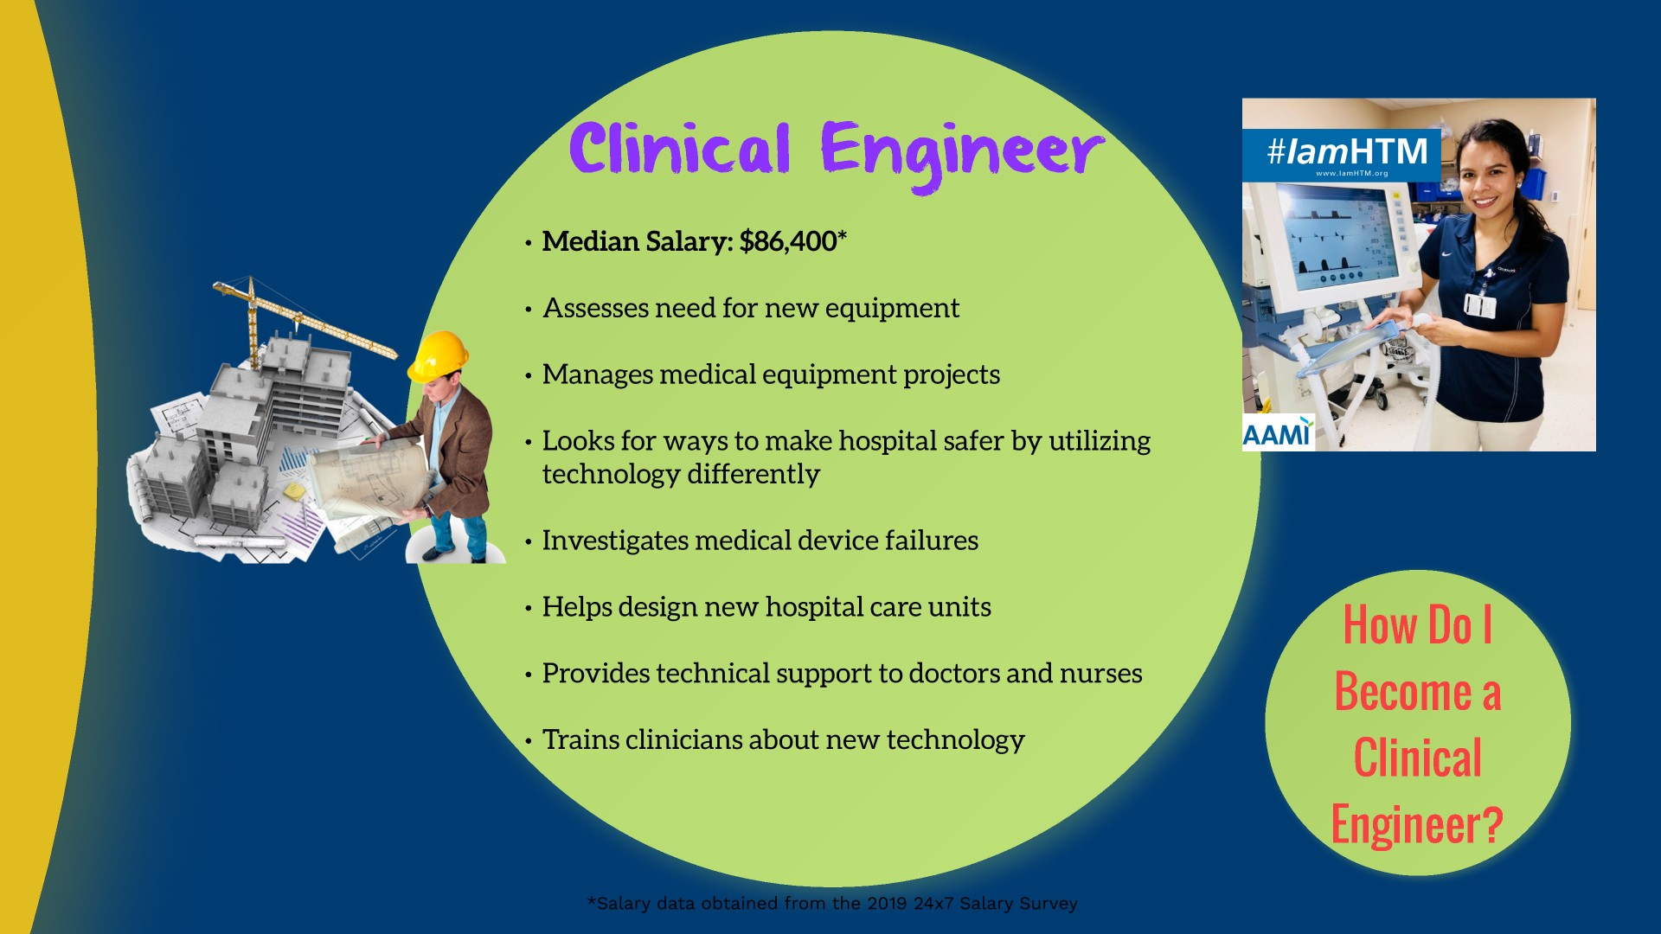

Notes:
- The salaries listed are the median salaries for the entire US. You may want to have more specific salaries prepared for your geographical area.
- If you are talking to a group of Engineering students, you will want to spend more time going over this job role.
- Give examples for each bullet point.
- Reiterate that you will continue to learn for the rest of your career and clinical engineers are always looking for ways to solve problems in the hospital to improve safety and make care more efficient.
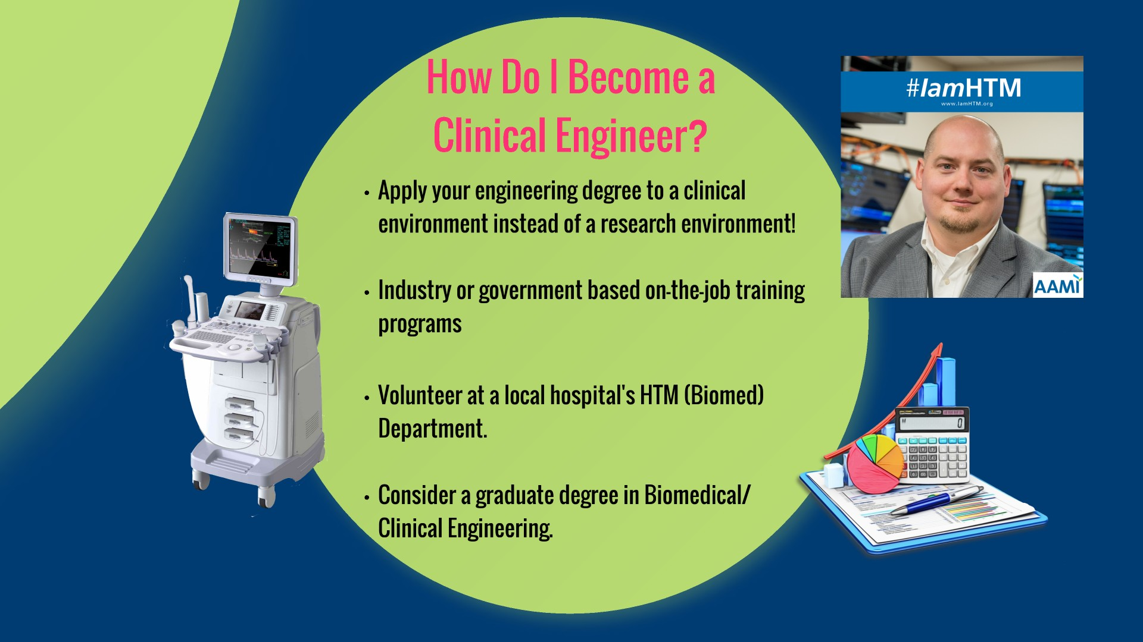

Notes:
- This is our time to convince students that HTM is the career option they want to choose, if they are studying engineering. Let the students know that they do not have to be in a lab or an R&D environment. This is a career where they can use their engineering skills in the hospital every day.
- If the audience is in school or a group of career changers, stress the importance of volunteering in the HTM department as an entry point into the field.
- Explain that some hospitals call their HTM Departments: Clinical Engineering, Biomedical Engineering or Biomed when they call looking to volunteer.
- Be sure to mention the Clinical Engineering master’s program at the University of Connecticut or the maters degree program of Healthcare Technologies Management at Marquette.
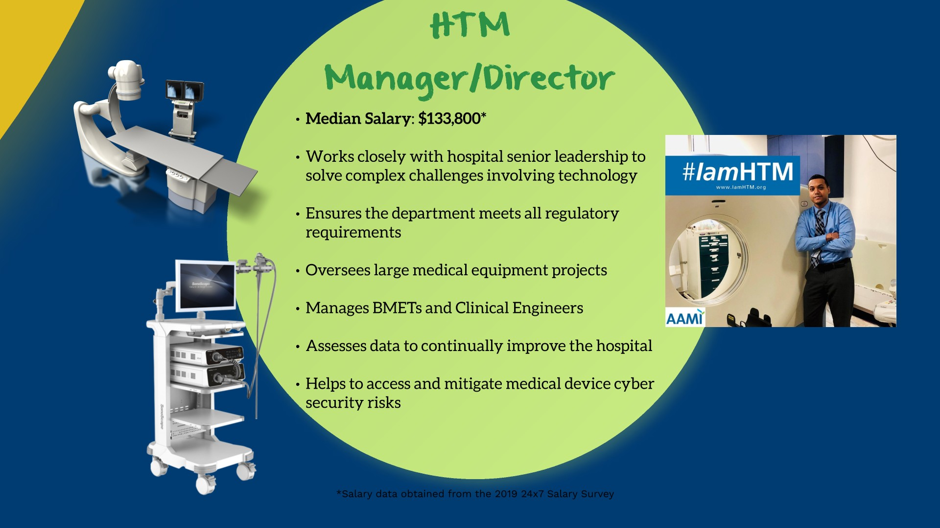

Notes:
- The salaries listed are the median salaries for the entire US. You may want to have more specific salaries prepared for your geographical area.
- It is important to spend some time talking about this slide to show that the profession has lots of growth opportunities. Explain how HTM departments at larger hospitals offer department manager and director rolls to move into. There are also regional director and manager opportunities available at third-party service organizations and/or medical device manufacturers.
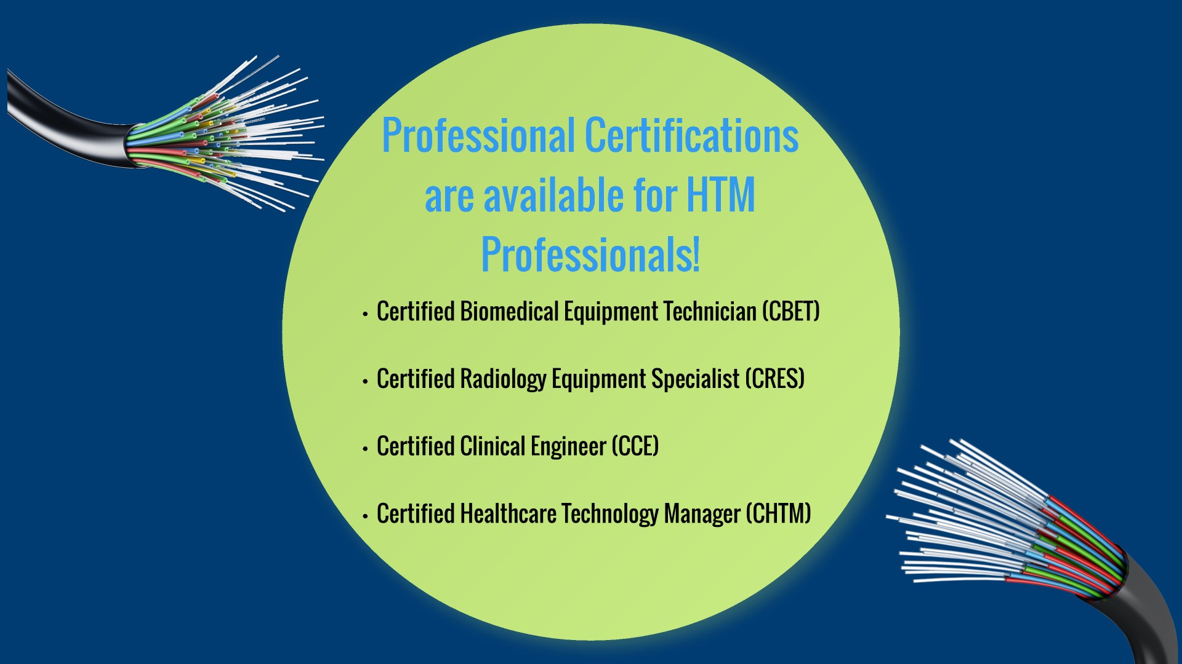

Notes:
- This slide is meant to let people know that professional certification is available in the field. Do not talk about any of these certifications in depth unless there are specific questions.
- Make sure to distinguish that certification and licensure is different and an HTM Certification is not required to work in the field. However, many organizations do require it for advancement.
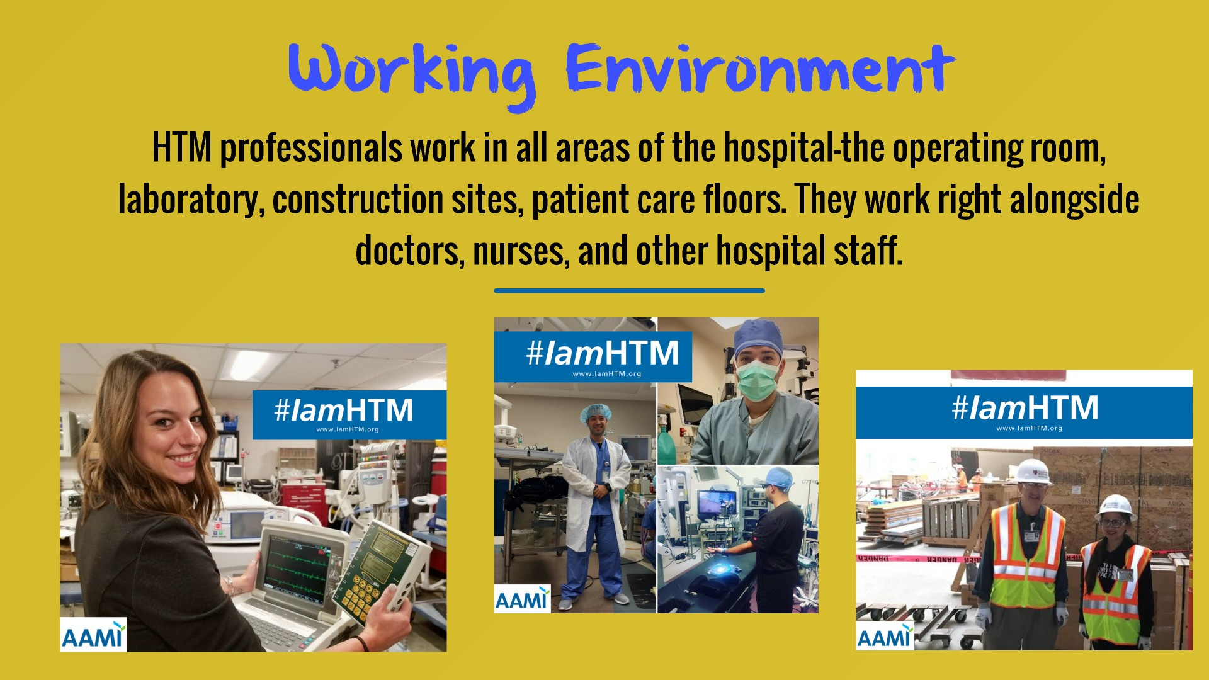

Notes:
- Mention all the places that HTM professionals can work in the hospital.
- Give examples of what HTM professionals do in each area.
- Mention all the different people and hospital staff you encounter every day.
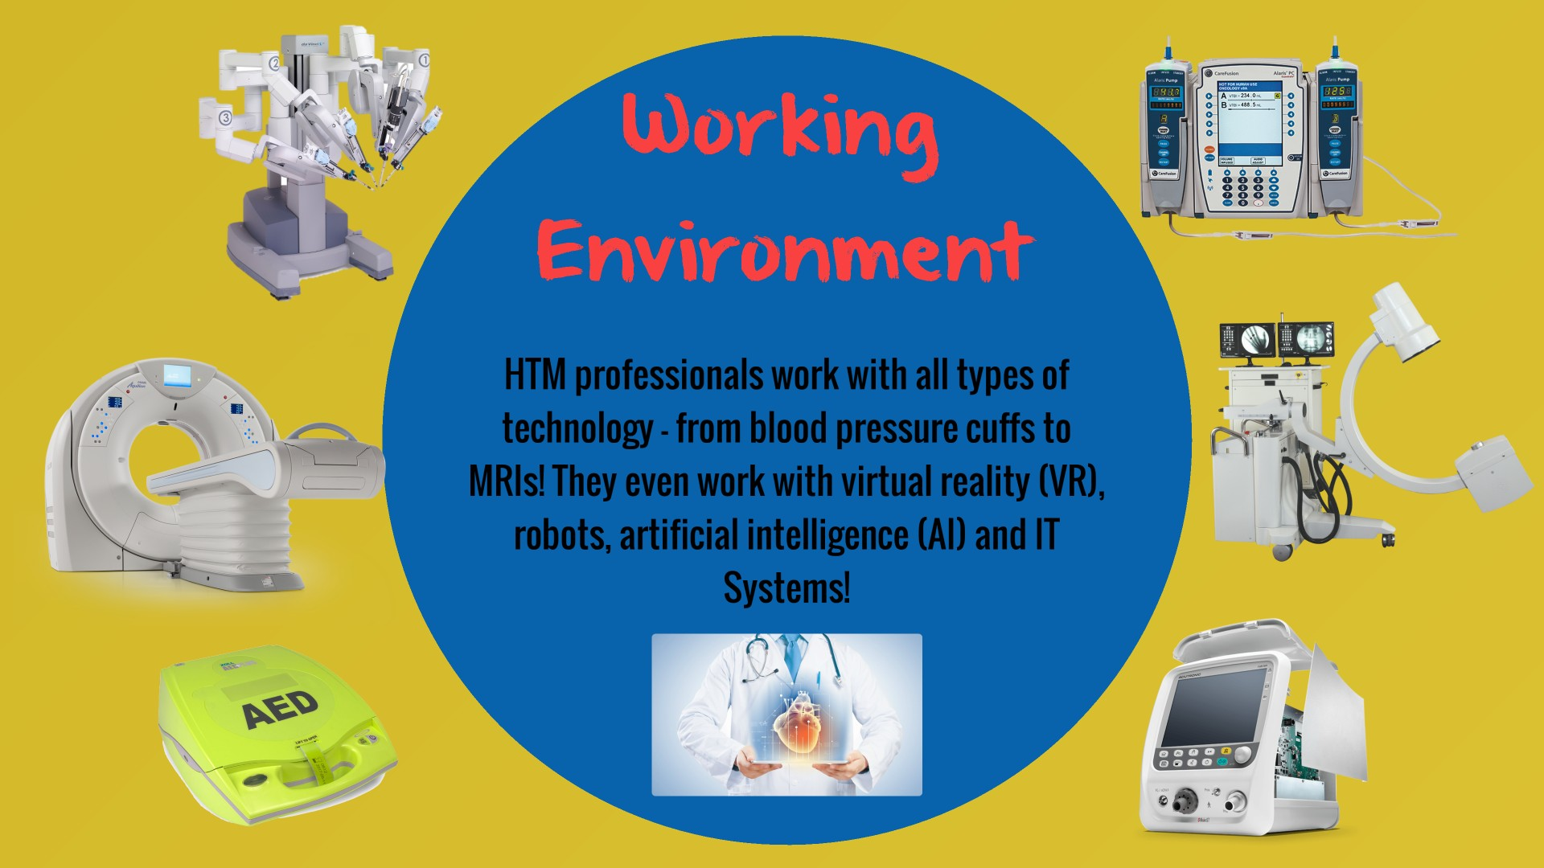

Notes:
- Talk about all the different types of equipment you encounter each day.
- Point out the different types of equipment shown on this slide.
- This is a great place to mention how medical equipment has gotten more and more IT based and interoperable. Talk about HTM’s role in the convergence of the HTM and IT fields and the role HTM professionals now play in cybersecurity.
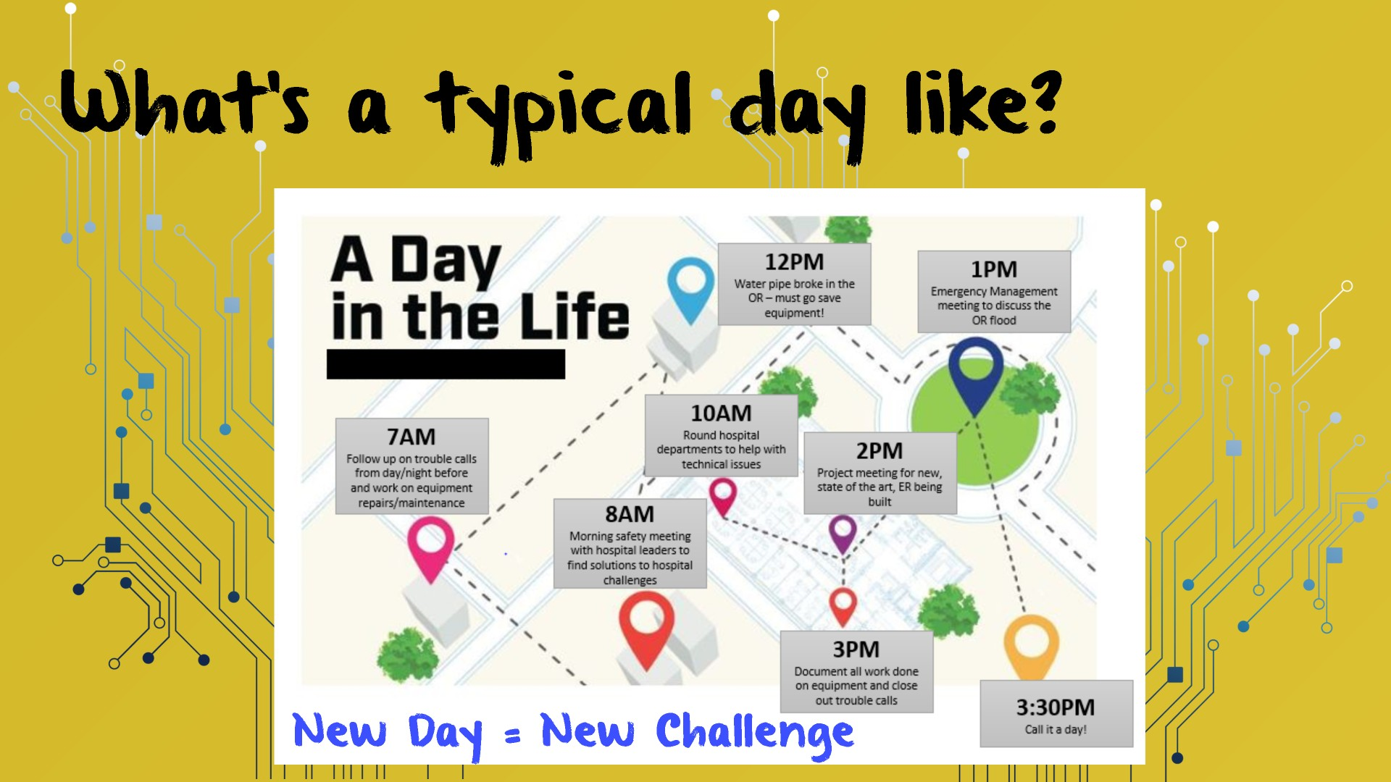

Notes:
- Walk through this slide box by box – explaining each action and why it is important.
- Explain how unpredicatable your day can be and how no day is the same.
- Ensure the audience understand that whether you are a BMET, Clinical Engineer, or HTM Manager/Director, you will have a role in all these action items. Depending upon your position, your role you play in each issue will be different, but you will be involved in all these areas.

Notes:
- Tell the audience again why you love HTM. Reinforce your love for the profession - enthusiasm and passion are contagious.
- Stress how the career enables you to make a meaningful difference in the lives of others.
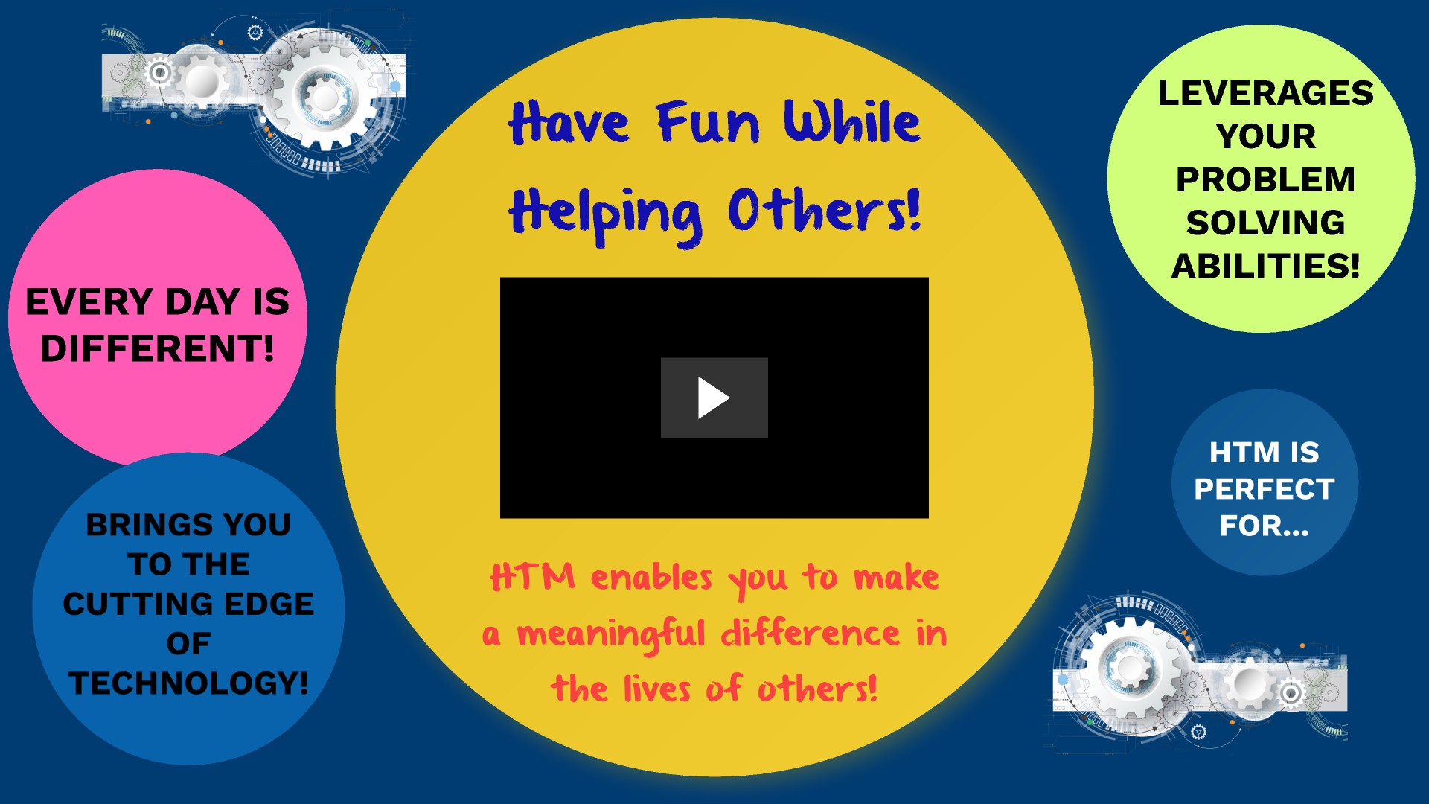
- Fun Fact: Mention that the video music track is made 100% of medical device sounds. Nothing was added in to supplement the track

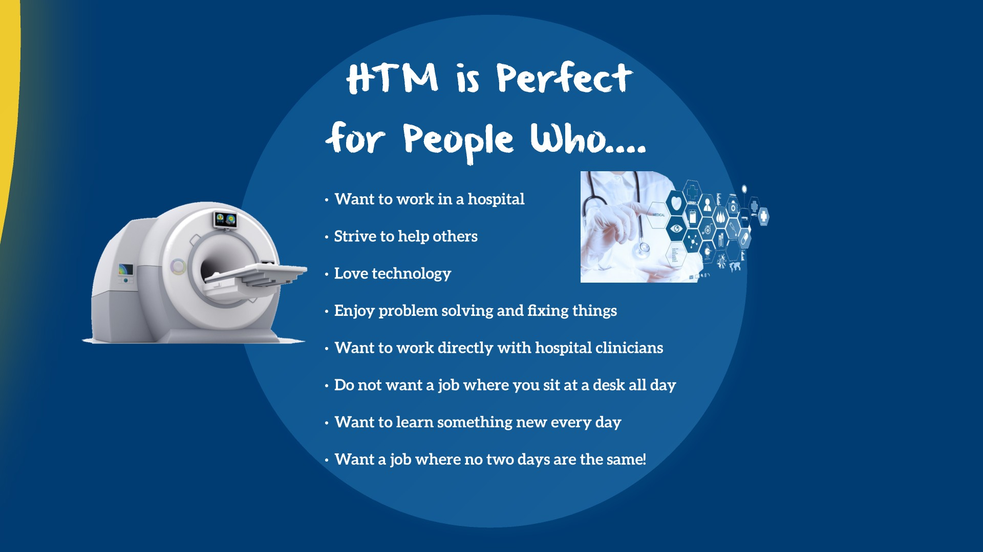
Notes:
- Stress all these points to the audience.
- The more excited you are about the career, the more excited the audience will be!

Notes:
- Emphasize that additional information about the field can be found at www.IamHTM.org
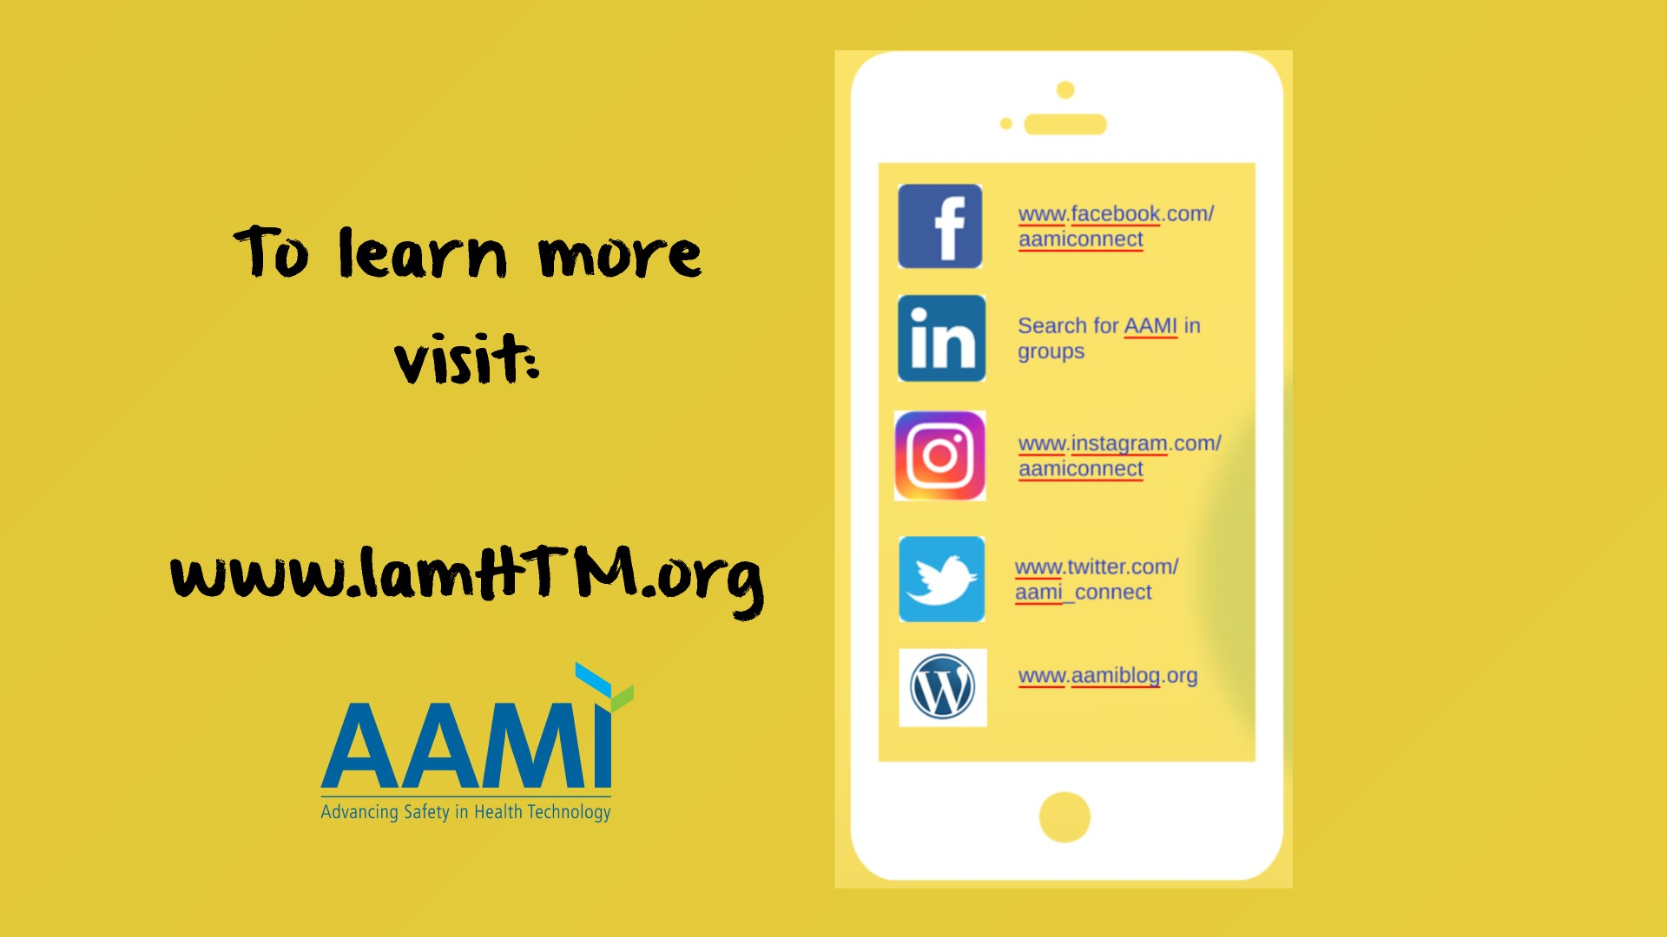
- Encourage students to follow AAMI and/or the hashtag #IamHTM on social media.

